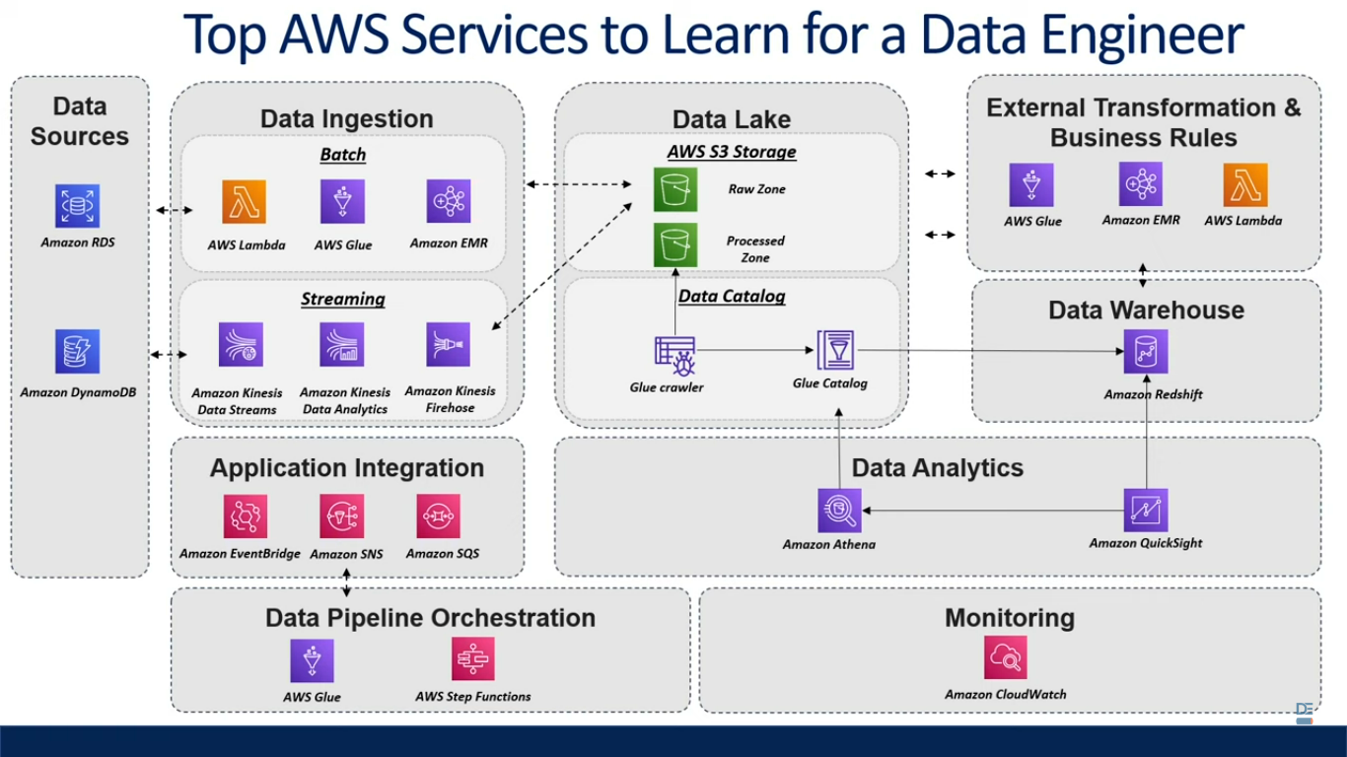

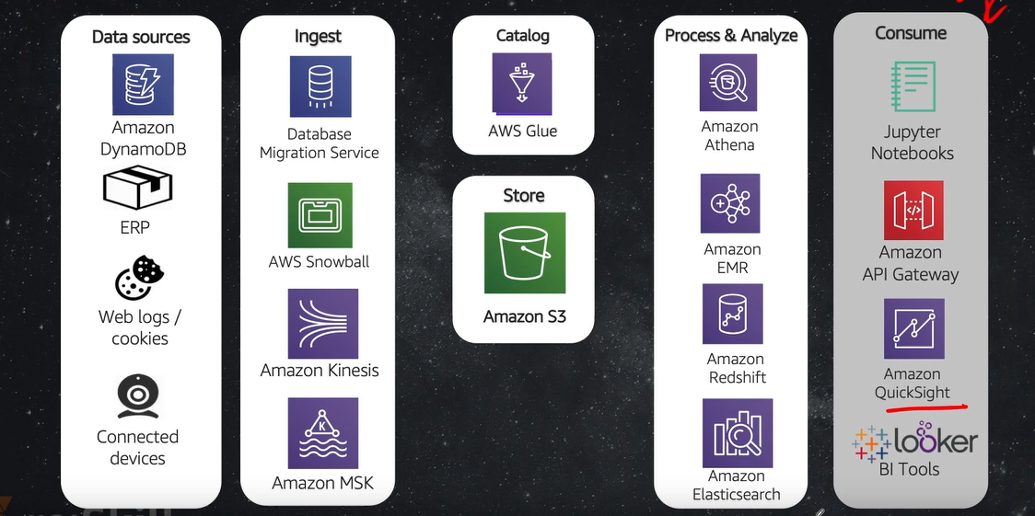

**=====================================================================**

**AWS S3** - Storage service that allow enterprise/individuals to store and protect any amount of data. Helps in fine-tuned access controls.

**AWS RDS** - Amazon RDS is a collection of managed services that makes it simple to set up, operate, and scale databases in the cloud. Choose from seven popular engines — Amazon Aurora with MySQL compatibility, [Amazon Aurora with PostgreSQL compatibility](https://aws.amazon.com/rds/aurora/?pg=ln&sec=hiw), [MySQL](https://aws.amazon.com/rds/mysql/?pg=ln&sec=hiw), [MariaDB](https://aws.amazon.com/rds/mariadb/?pg=ln&sec=hiw), [PostgreSQL](https://aws.amazon.com/rds/postgresql/?pg=ln&sec=hiw), [Oracle](https://aws.amazon.com/rds/oracle/?pg=ln&sec=hiw), and [SQL Server](https://aws.amazon.com/rds/sqlserver/?pg=ln&sec=hiw) — and deploy on-premises with [Amazon RDS on AWS Outposts](https://aws.amazon.com/rds/outposts/?pg=ln&sec=hiw).

====================================================================

**Date Lake** - Data Lake is a centralized repository that allows you to store all your structured and unstructured data at any scale.

AWS Lambda - AWS Lambda is an event-driven, serverless computing platform provided by Amazon as a part of Amazon Web Services. **It is a computing service that runs code in response to events and automatically manages the computing resources required by that code.**

Serverless - means as a user we don’t need to start and stop server manually it automatically does it.

---------------------------------------------------------------------------------------------------------------------------

**AWS DynamoDB -**

Fully managed, multi-region, multi master database.

NoSQL database(No need to define schema) engine that deliver reliable performance.

Auto Scalable and In-memory caching.

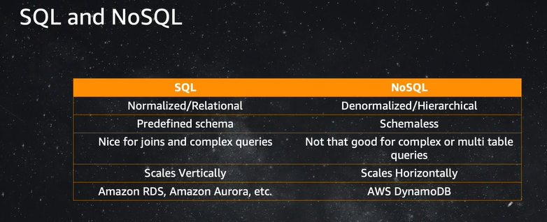

**No-SQL engine types** - Key-Value, Column-Oriented, Document-Oriented, Graph.

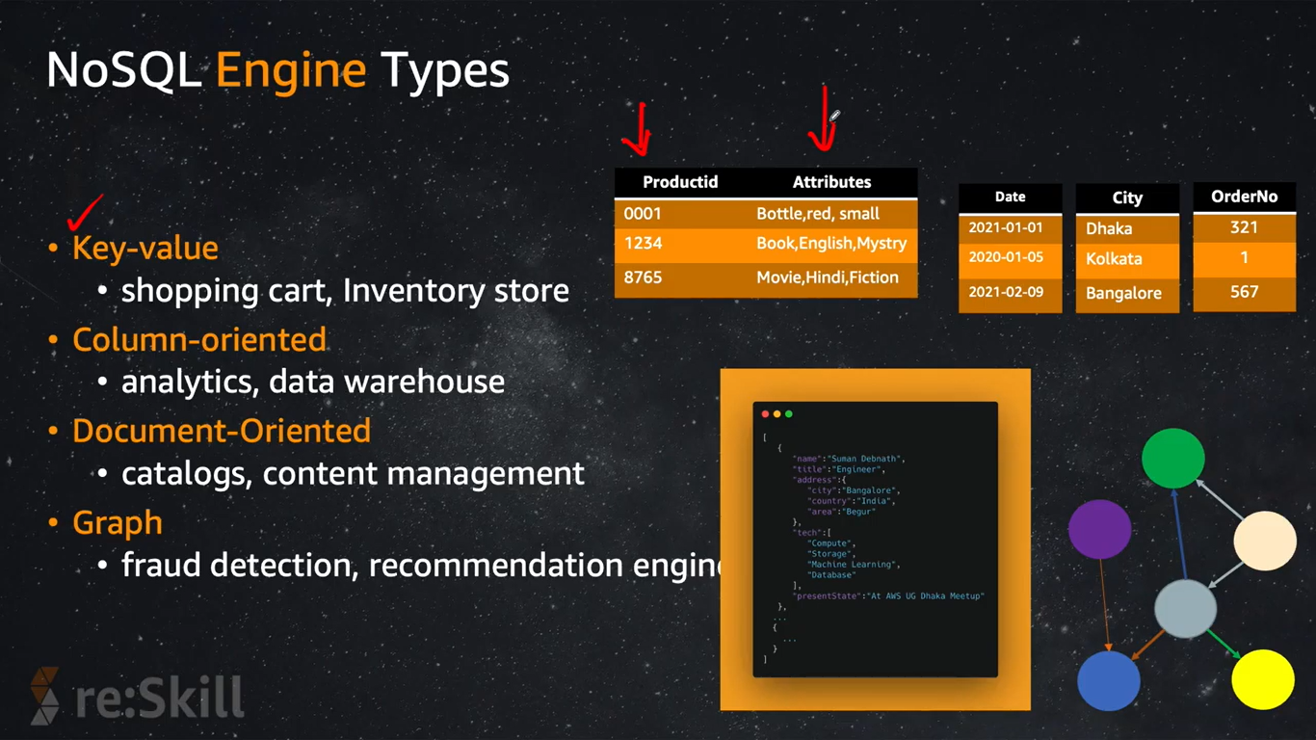

**When there is so much data the store is not scalable, so we use AWS DynamoDB.**

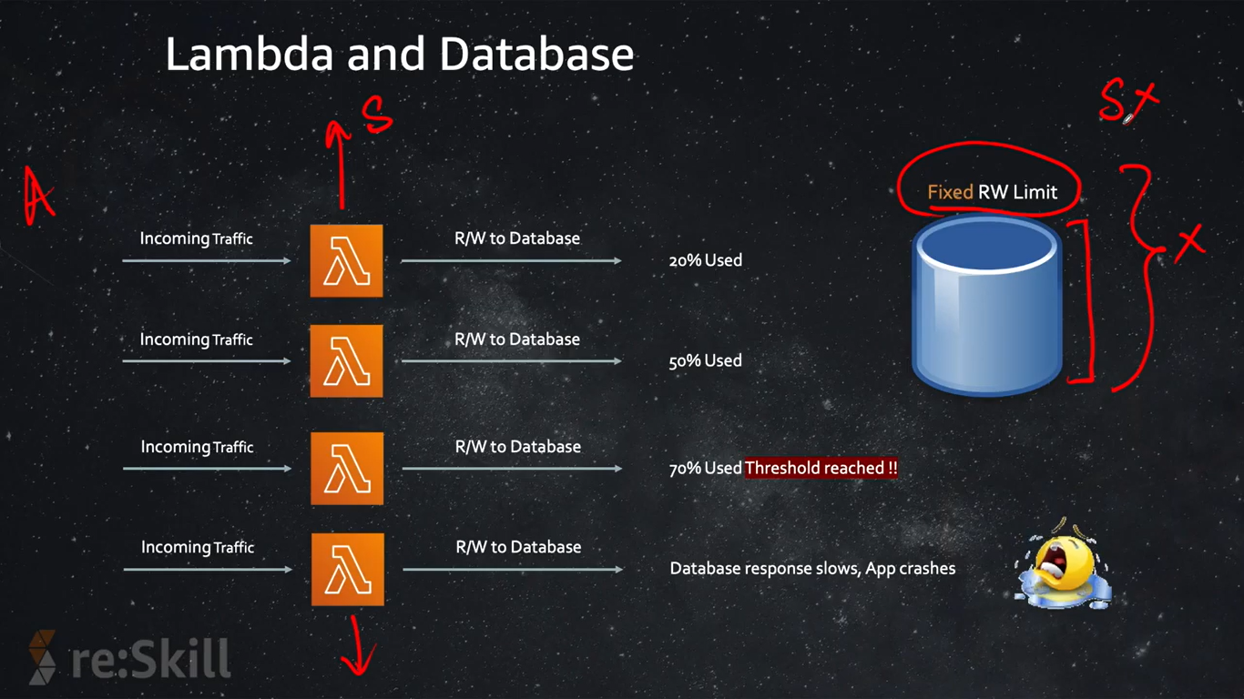

Using DynamoDB AWS does auto-scale so more storage.

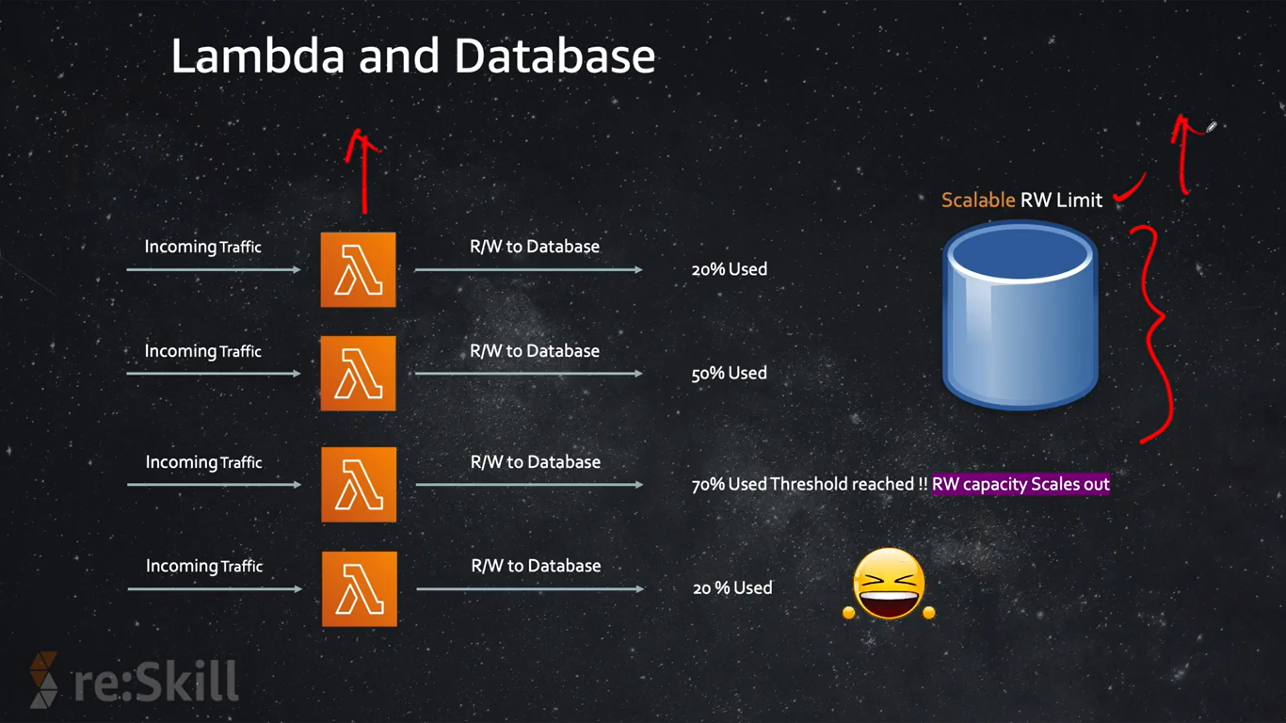

**ITEM in No-Sql is group of attributes.**

**Attribute** - Is a fundamental data element, something that doesn’t need to be broken down any further.

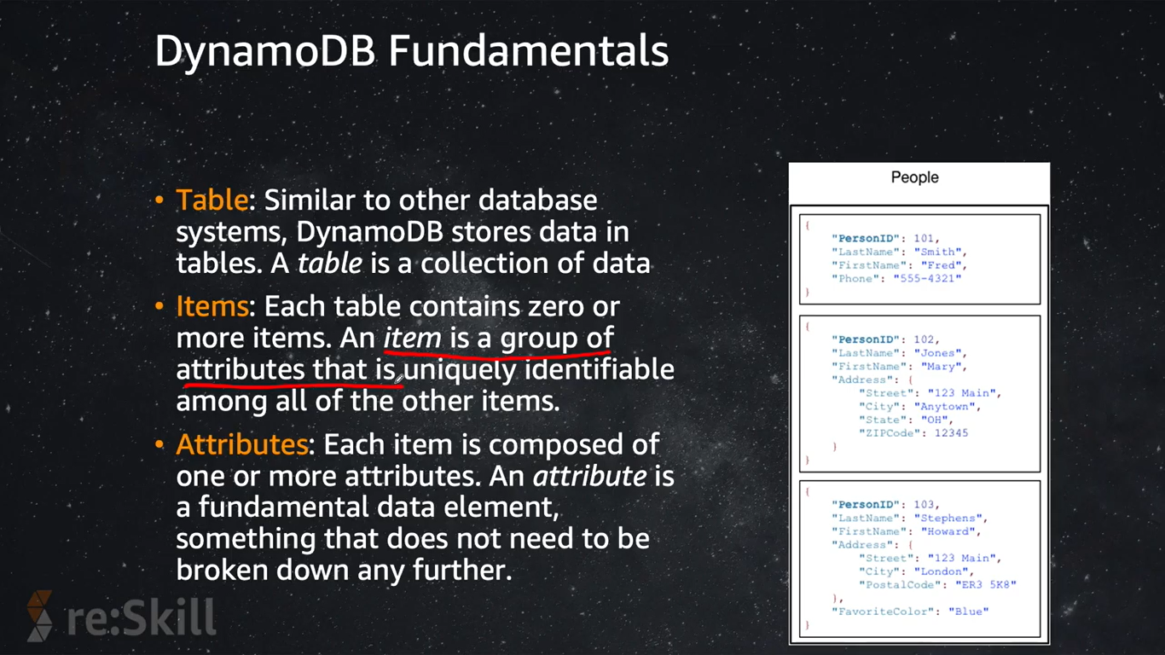

**Primary key((partition key),clusteringkey1, clusteringkey2)**

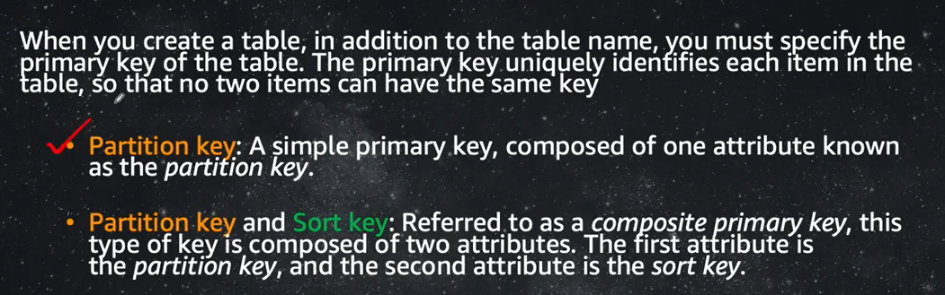

When you **combine partition key and sort key, you get primary key.** That is how uniqueness is defined.

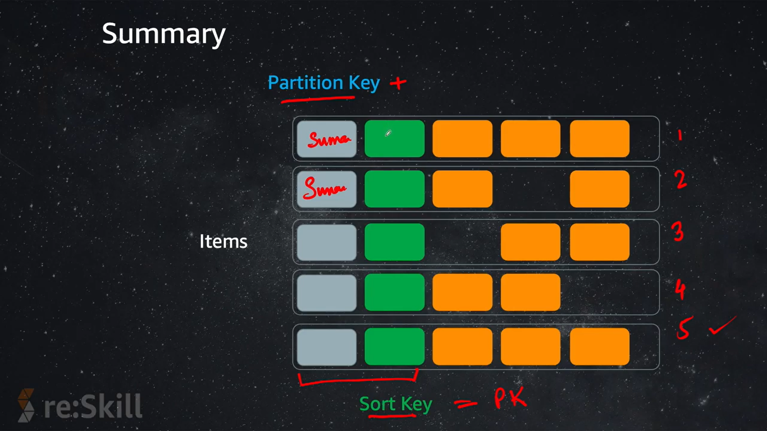

**----------------------------------------------------------------------------------------------------------------------------**

**AWS Read Consistency**

DynamoDB supports both *eventually consistent* and *strongly consistent* reads.

**Eventually Consistent Reads**

When you read data from a DynamoDB table, the response might not reflect the results of a recently completed write operation. The response might include some stale data. If you repeat your read request after a short time, the response should return the latest data.

**Strongly Consistent Reads**

When you request a strongly consistent read, DynamoDB returns a response with the most up-to-date data, reflecting the updates from all prior write operations that were successful. However, this consistency comes with some disadvantages:

* A strongly consistent read might not be available if there is a network delay or outage. In this case, DynamoDB may return a server error (HTTP 500).
* Strongly consistent reads may have higher latency than eventually consistent reads.
* Strongly consistent reads are not supported on global secondary indexes.
* Strongly consistent reads use more throughput capacity than eventually consistent reads.

**----------------------------------------------------------------------------------------------------------------------------**

**AWS Read-Write Capacity Mode**

Amazon DynamoDB has two read/write capacity modes for processing reads and writes on your tables:

* On-demand
* Provisioned (default, free-tier eligible)

The read/write capacity mode controls how you are charged for read and write throughput and how you manage capacity. You can set the read/write capacity mode when creating a table or you can change it later.

**----------------------------------------------------------------------------------------------------------------------------**

**AWS Cloud9**

*AWS Cloud9* is a cloud-based integrated development environment (IDE) that lets you write, run, and debug your code with just a browser.

**CREATE A TABLE in AWS CLI**

**-----------------**

**aws dynamodb\**

**create-table\**

**--table-name PetInventory \**

**--attribute-definitions \**

**AttributeName=pet_species,AttributeType=S \**

**AttributeName=pet_id,AttributeType=N \**

**--key-schema \**

**AttributeName=pet_species,KeyType=HASH \**

**AttributeName=pet_id,KeyType=RANGE \**

**--billing-mode PAY_PER_REQUEST**

**Describe A Table**

**--------------------**

**aws dynamodb\**

**describe-table\**

**--table-name PetInventory**

**List Table**

**-----------------------**

**aws dynamodb\**

**list-tables**

**Delete Table**

**------------------------**

**aws dynamodb\**

**delete-table \**

**--table-name PetInventory**

----------------------------------------------------------------------------------------------------------------------------

Boto 3 - An SDK in python. Using boto3 use access and use any AWS resource.

Create Table using SDK

import boto3

def create_movie_table(table_name):

dynamodb =boto3.client("dynamodb")

table = dynamodb.create_table(

TableName=table_name,

KeySchema=[

{

'AttributeName':'year',

'KeyType' :'HASH' #PartitionKey

},

{

'AttributeName':'title',

'KeyType':'RANGE'#sort key

}

],

AttributeDefinitions=[

{

'AttributeName':'year',

'AttributeType':'N'

},

{

'AttributeName':'title',

'AttributeType':'S'

},

],

ProvisionedThroughput={

'ReadCapacityUnits':10,

'WriteCapacityUnits':10

}

)

return table

#create Table

table_name="Movies"

create_movie_table(table_name=table_name)

#status

dynamodb=boto3.resource('dynamodb')

table=dynamodb.Table(table_name)

print("Table Status:", table.table_status)

--------------------------------------------------------------------------------------------------------------------------

Loading the data

"""

Load The Data

"""

from decimal import Decimal

import json

import boto3

def load_data(data):

dynamodb = boto3.resource('dynamodb')

table =dynamodb.Table('Movies')

for item in data[:100]:

year = int(item['year'])

title =item['title']

print("Addiding movie:",year,title)

table.put_item(Item=item)

#starts here

if __name__=='__main__':

with open("data.json") as json_file:

movie_list=json.load(json_file, parse_float=Decimal)

load_data(movi_list)

-----------------------------------------------------------------------------------------------------------------------

"""

Add New Item in table

"""

from print import print

import boto3

def put_movie(title,year, plot, rating):

dynamodb =boto3.resource('dynamodb')

table = dynamodb.Table('Movies')

response =table.put_item(

Item ={

'year':year,

'title':title,

'info': {

'plot':plot,

'rating':rating

}

}

)

return response

#start here

if __name__ =='__main__':

movie_resp =put_movie("The big New Movie", 2015,"Nothing happens at all",0)

print("Put movie succeded")

pprint(movie_resp)

--------------------------------------------------------------------------------------------------------------------------

"""

How to query the record

"""

import boto3

from boto3.dynamodb.conditions import Key

def query_movies(year):

dynamodb=boto3.resource('dynamodb')

table =dynamodb.Table('Movies')

response = table.query(KeyConditionExpression=Key('year').eq(year))

return response['Items']

if __name__=='__main__':

query_year =2015

print(f"Movies from {query_year}")

movies = query_movies(query_year)

for movie in movies:

print(movie['year'],":",movie['title'])

---------------------------------------------------------------------------------------------------------------------------

"""

Delete table

"""

import boto3

def delete_movie_table():

dynamodb=boto3.resource('dynamodb')

table =dynamodb.Table('Movies')

table.delete()

#Starts here

if __name__ =='__main__':

delete_movie_table()

print("Movies table deleted")

=====================================================================

**Amazon Kinesis**

Kinesis is a managed service alternative to Apache Kafka.

Application logs, metrics, IOT, Clickstreams.

Great for streaming processing frameworks.

Data is automatically replicated synchronously to 3 to AZ.

Kinesis is family of service.

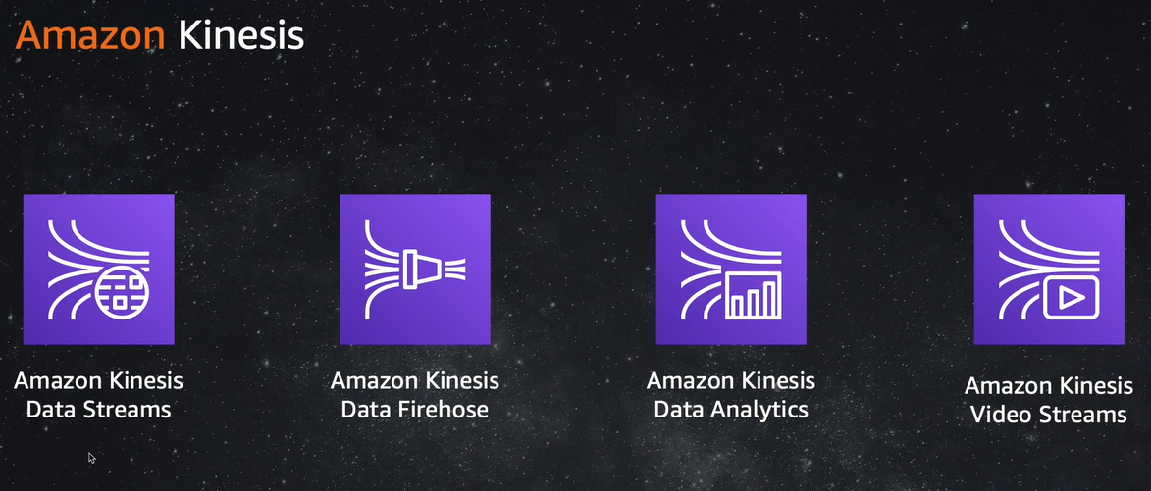

1. AWS Kinesis Data Streams.
2. AWS Kinesis Data Firehouse.
3. AWS Kinesis Data Analytics.
4. AWS Kinesis Video streams.

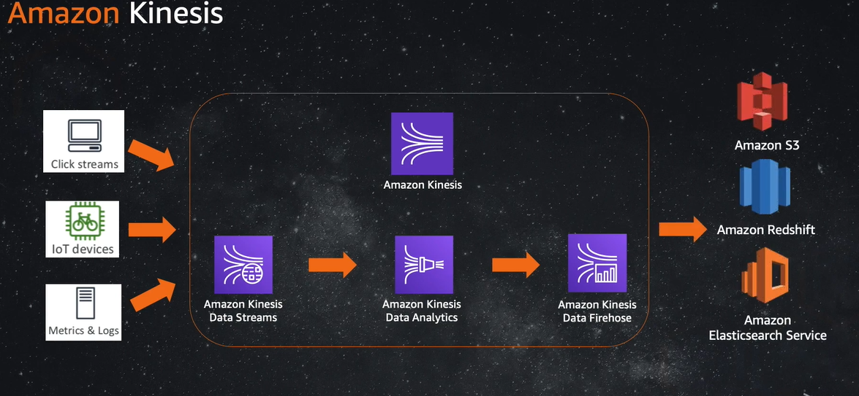

Kinesis Stream Shard - One stream is made of many shards.

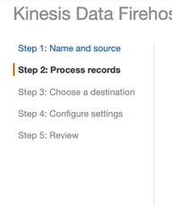

Create a AWS Kinesis data firehouse - you need source(you can inject using python and boto3 sdk).

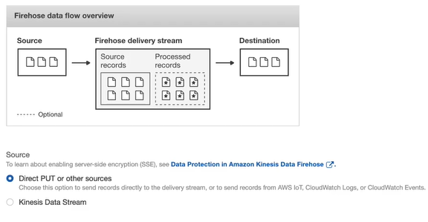

Processing records

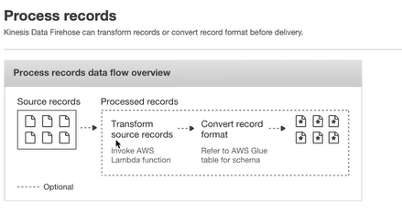

Storing data after processing.

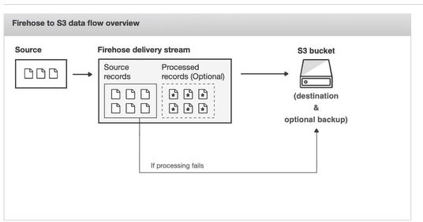

**Once you create the stream then you push the data.**

====================================================================

**AWS S3(simple store system) - Data Lake Storage on AWS**

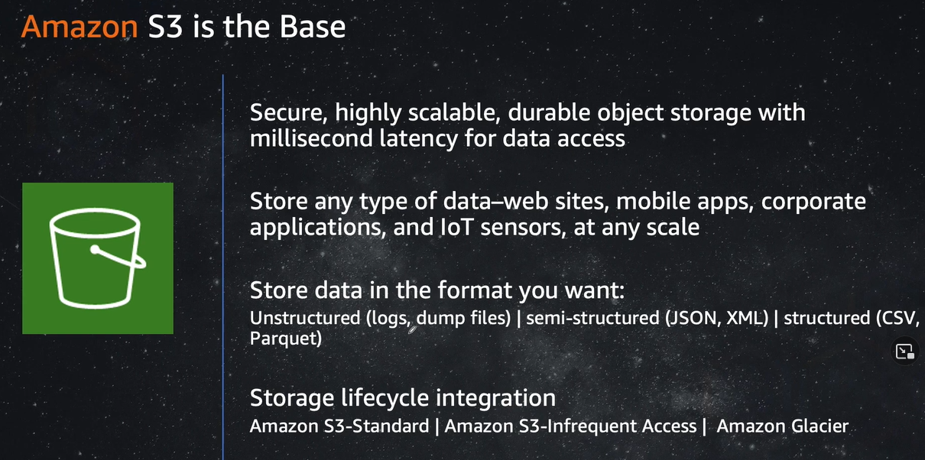

AWS S3 is simple store service which let to store and retrieve any amount of data.

Latency should considered while creating the s3 bucket(if near region the better)

The Naming convention should be followed.

**Versioning** of data. Like keeping copy of data.

Cross region replication - If you had created bucket 1 in region 1 and bucket 2 in region 2 you can transfer the data one to another.

=====================================================================

**AWS Glue - Serverless Data Catalog and ETL. Automatically discovers data and stores schema. Generate customizable code.**

**AWS Glue is recommended when your use cases are primarily ETL and when you want to run jobs on a serverless Apache Spark-based platform.**

Using AWS glue you crawl the data from table and store is as metadata which is referred as data catalog.

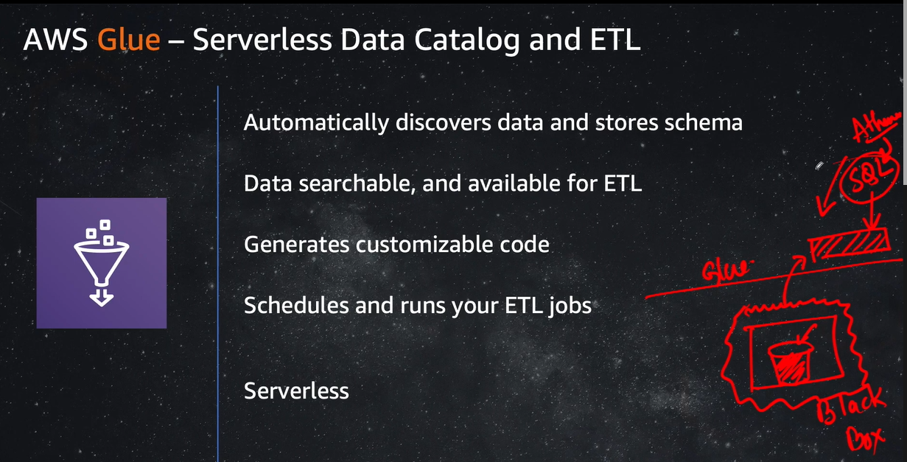

**ETL jobs in Glue**

If you want to completely transfer a data you can create a **job.** You can do like converting csv file into parquet format.

This job automatically create spark script. [Very important remember]

ETL Process mean - transfer Source data to Data warehouse. Glue is a fully managed ETL(Extract, Transfer, Load) that make simple and cost effective for categorize data, clean data between various data sources.

Glue can be used to create event based ETL pipeline(As the data comes to process data)

Glue data catalog of tables.

We can use the metadata that is Data Catalog of tables. Then use that data when we define the job[Job is basically an business logic for transforming the data] to transfer the data.

AWS Glue can also generate spark script for data transformation.

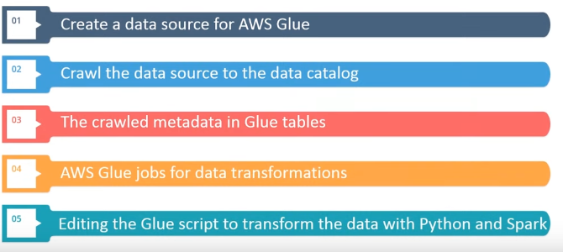

==================================================================

**AWS Redshift** - Amazon Redshift is a fully managed, petabyte-scale data warehouse service in the cloud. Used to perform business analytics. Redshift uses a unique data warehouse architecture called **Massively parallel processing**.

Data Modeling in Data Ware House

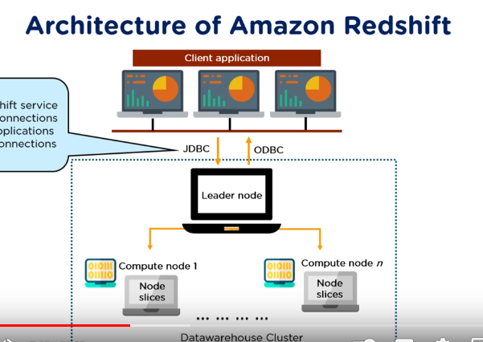

AWS Redshift has COLUMN Storage(similar to tabular table) and COMPRESS storage(It is a column level operation which decrease the storage requirements)

Recently I was working of COVID dataset. Where I had the data of Covid cases, Patients detailes in different tables. What I did was created a dimension schema(which star schema) to store the data.

**=====================================================================**

**The best part of AWS is the ..It is very well documented. Using which we can learn a lot and us the service as per of requirement.**

**====================================================================**

**AWS Athena - Interactive Analysis.**

On what you have crawl the data using glue service and store in glue tables, you can use Athene to query the data as rows/item.

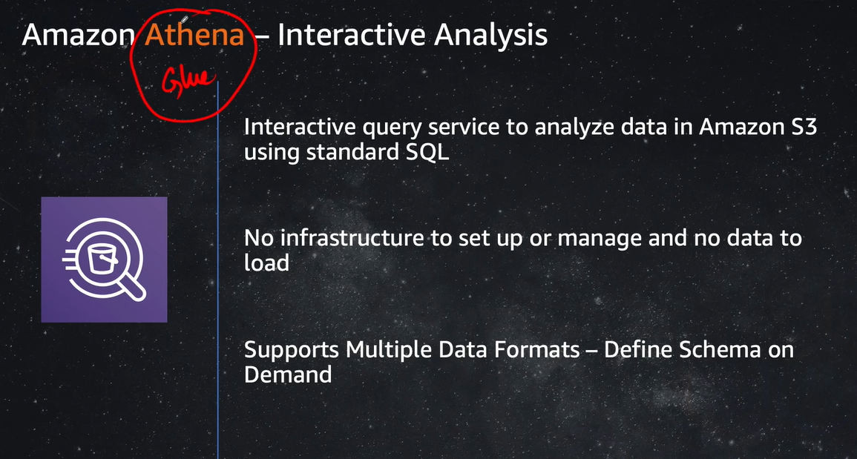

**=====================================================================**

**AWS Lambda**

## **What Is AWS EC2?**

EC2, is a virtual machine in the cloud on which you have OS-level control.

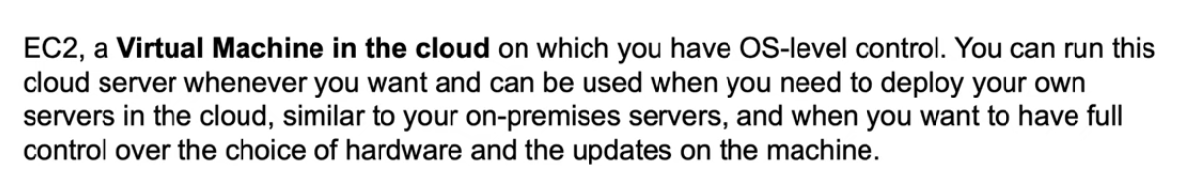

AWS EC2 (Amazon Web Services Elastic Compute Cloud) is a service that allows for using virtual machines called EC2 instances in the cloud and providing scalability. You can change the amount of disk space, CPU performance, memory etc. whenever you need. You can select the base image with the necessary pre-installed operating system (OS) such as Linux or Windows and then configure most OS settings as well as installing custom applications. You have the root access for your Amazon EC2 instances and can create additional users.

AWS Lambda

## **What Is AWS Lambda?**

AWS Lambda is a computing platform that allows you to run a piece of code written on one of the supported programming languages – Java, JavaScript, or Python **when a trigger linked to an event is fired.** You don’t need to configure a virtual server and environment to run an application you have written. Just insert your program code (called Lambda function in this case) in the AWS Lambda interface, associate the Lambda function with the event and run the application in the cloud when needed, without taking care of server management and environment configuration. This way, you can focus on your application, not on server management—**this is why AWS Lambda is referred to as serverless**.

An event after which your application is executed can be uploading a file to the Amazon S3 bucket, making changes in DynamoDB tables, getting an HTTP request to the API Gateway service, etc. After configuring a function to run when an event occurs, your application will be executed automatically after each new event.

**When using Lambda, you are responsible only for your code. Lambda manages the compute fleet that offers a balance of memory, CPU, network, and other resources to run your code. Because Lambda manages these resources, you cannot log in to compute instances or customize the operating system on** [**provided runtimes**](https://docs.aws.amazon.com/lambda/latest/dg/lambda-runtimes.html)**.**

## **AWS EC2 vs Lambda: Use Cases**

AWS EC2 has a wide range of use cases since almost everything can be configured when using this service. The most common use cases of AWS EC2 are:

* Hosting web sites
* Developing and testing applications or complex environments
* High performance computing
* Disaster recovery

General use cases of AWS Lambda:

* Automating tasks
* Processing objects uploaded to Amazon S3
* Real-time log analyzing
* Real-time filtering and transforming data

Let’s consider a particular example. Imagine that your web site uses an Amazon S3 bucket to store web-site content including pictures, videos, audio files, etc. When a new image or video file is uploaded, you need to create a preview image for your web page that is used as a link to a full size image or video file. Creating preview images manually can be a boring and time-consuming task. In this case, you can create a Lambda function that can automatically resize the image based on the uploaded picture, rename that image, and store the target image in the appropriate directory. You can configure the Lambda function to be executed right after the event of uploading the original image file to **the Amazon S3 bucket used by your web site.**

## **AWS EC2 vs Lambda: Working Principle**

EC2. As you may recall, when using AWS EC2, you operate with virtual machines (VMs) known as EC2 instances. You can add virtual hardware (virtual disks, network interfaces, processors, memory) to an EC2 instance, as well as start, stop, and reboot a VM instance. EC2 instances can work with two storage types – Elastic Block Storage (EBS) and S3 buckets. You can use a pre-configured image with an installed operating system and create your customized Amazon Machine Image (AMI). The EC2 cloud service provides automatic scaling and load balancing. EC2 instances can work in conjunction with most other Amazon web services, such as S3, ECS, Route53, Cloudwatch, etc.

Lambda. When using AWS Lambda, your application (Lambda function) is running in a container that is seamless for you. The container contains code and libraries. Resources are provided by Amazon in accordance with application needs, and scaling is automatic and seamless. You cannot control neither a container running your application nor an EC2 instance on which the container is running (you don’t know anything about them because the underlying infrastructure is unavailable for Amazon Lambda users). Refer to the table above.

AWS Lambda can be considered as a framework of EC2 Container Service (ECS) that uses containers to run a piece of code that represents your application. The life cycle of each container is short. The running Lambda function doesn’t save its state. If you want to save results, they should be kept in some data storage, for example, in an Amazon S3 bucket. It is possible to configure a virtual network for a Lambda function, for example, for connecting to Amazon RDS (Amazon Relational Database Service). Lambda consists of multiple parts: layers, function environment, and a handler. Triggers are Lambda activators. Lambda is one function that is executed by queries from triggers.

The complete list of available triggers:

* API Gateway
* AWS IoT
* Alexa Skills Kit
* Alexa Smart Home
* Application Load Balancer
* CloudFront
* CloudWatch Events
* CloudWatch Logs
* CodeCommit
* Cognito Sync Trigger
* DynamoDB
* Kinesis
* S3
* SNS
* SQS

API Gateway is a special service that allows developers to connect diverse non-AWS applications to AWS applications and other resources.

**How to access EC2 using lambda?**

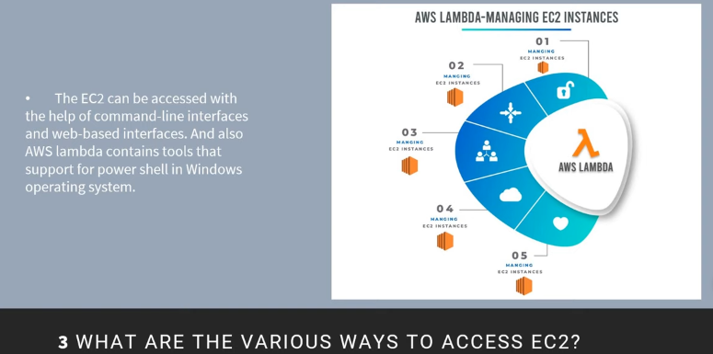

**What are the ways in which AWS lambda can be triggered?**

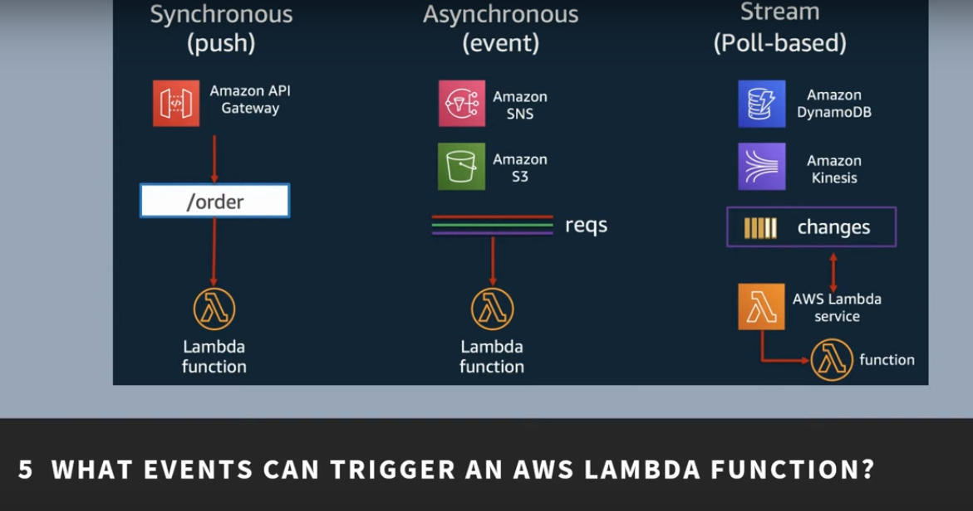

**How long the AWS lambda runs. →15 mins(updated). 6 - second (default timeout)**

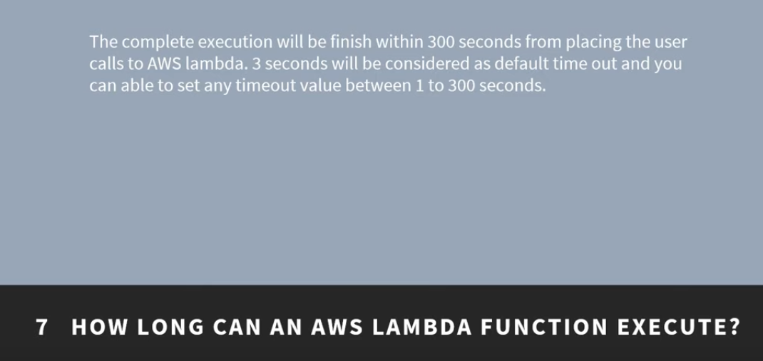

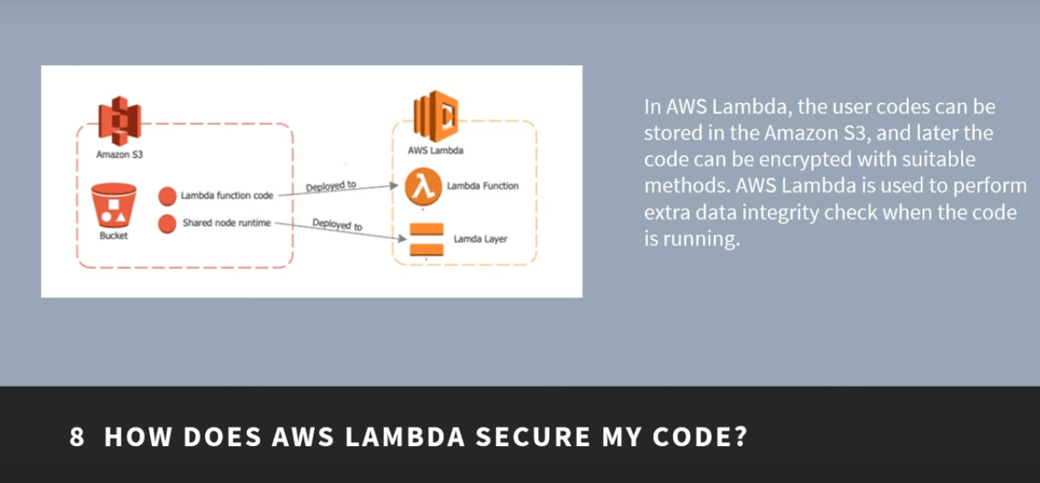

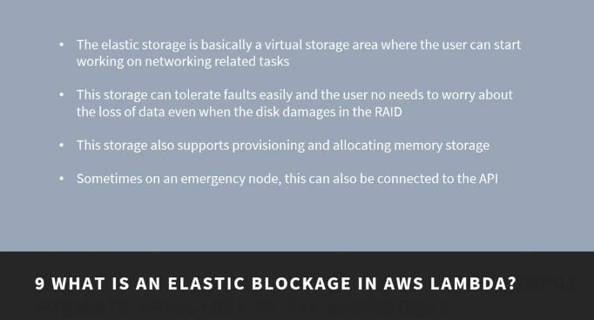

**What AWS SQS?**

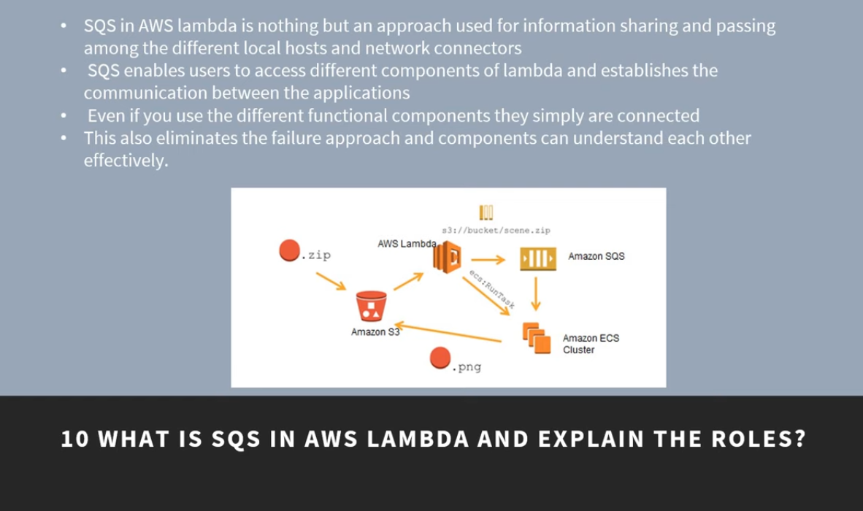

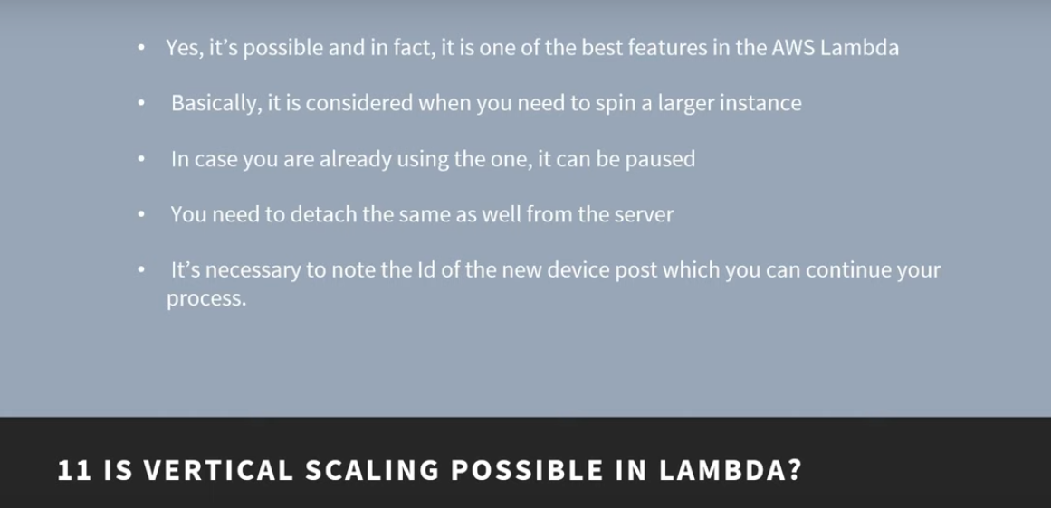

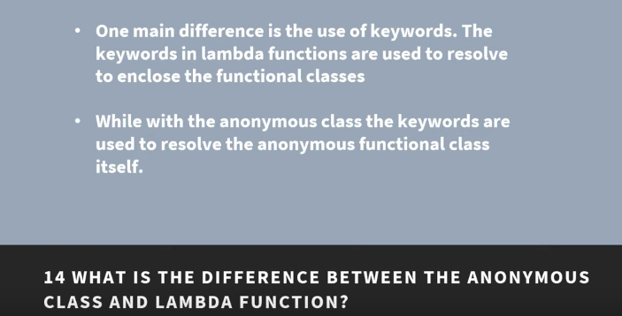

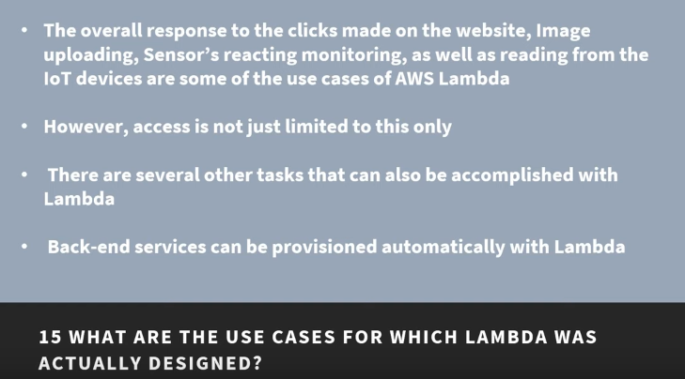

## **Amazon Virtual Private Cloud( AWS VPC)**

**---------------------------------------------------------------------------------------------------------------------------**

**What is Snowball?**

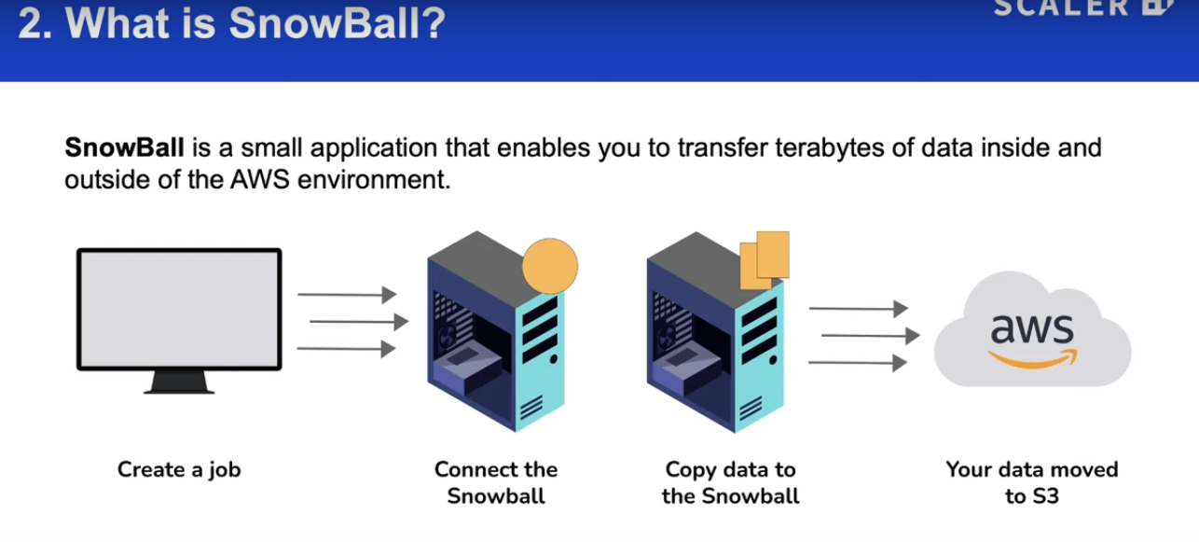

---------------------------------------------------------------------------------------------------------------------------

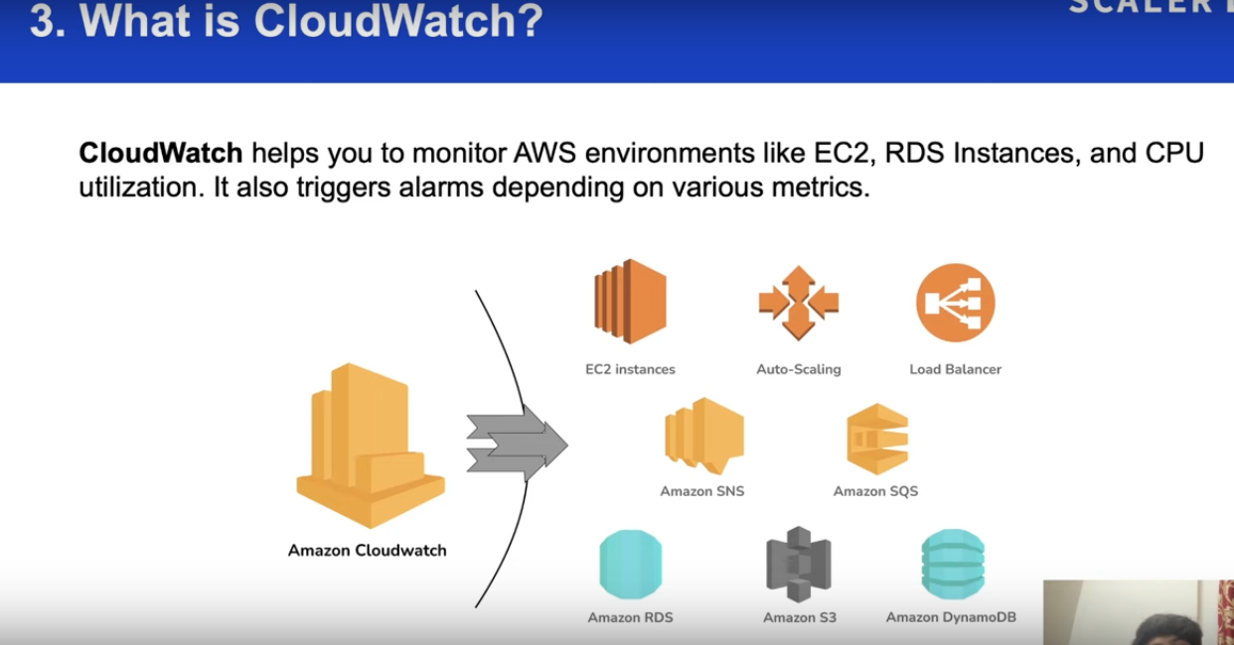

---------------------------------------------------------------------------------------------------------------------------

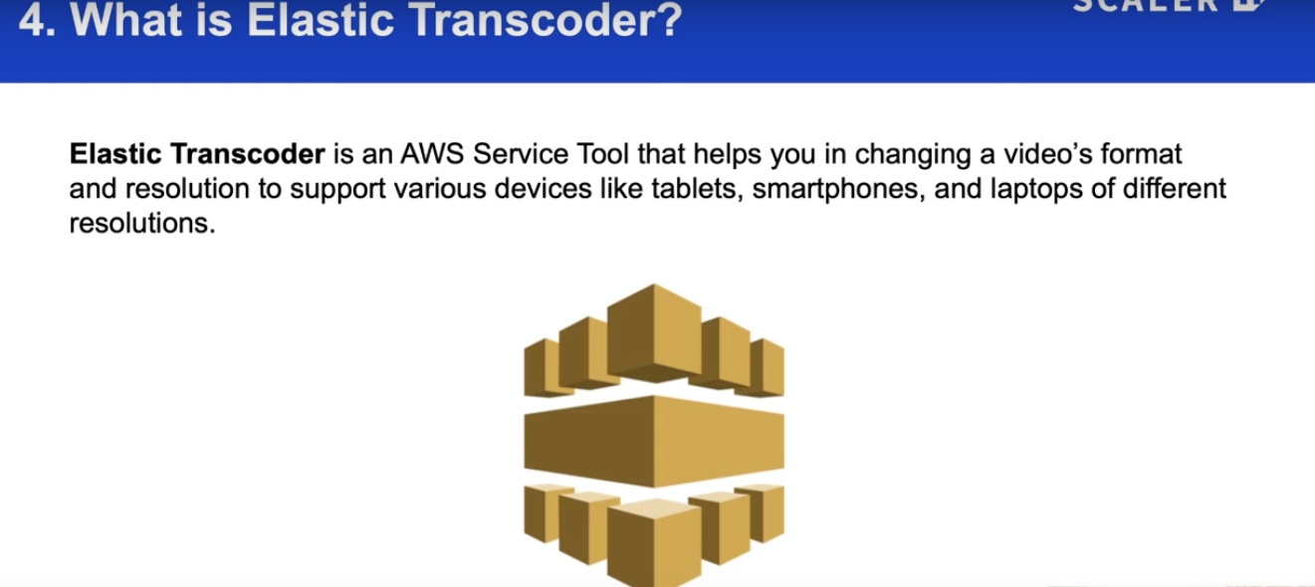

---------------------------------------------------------------------------------------------------------------------------

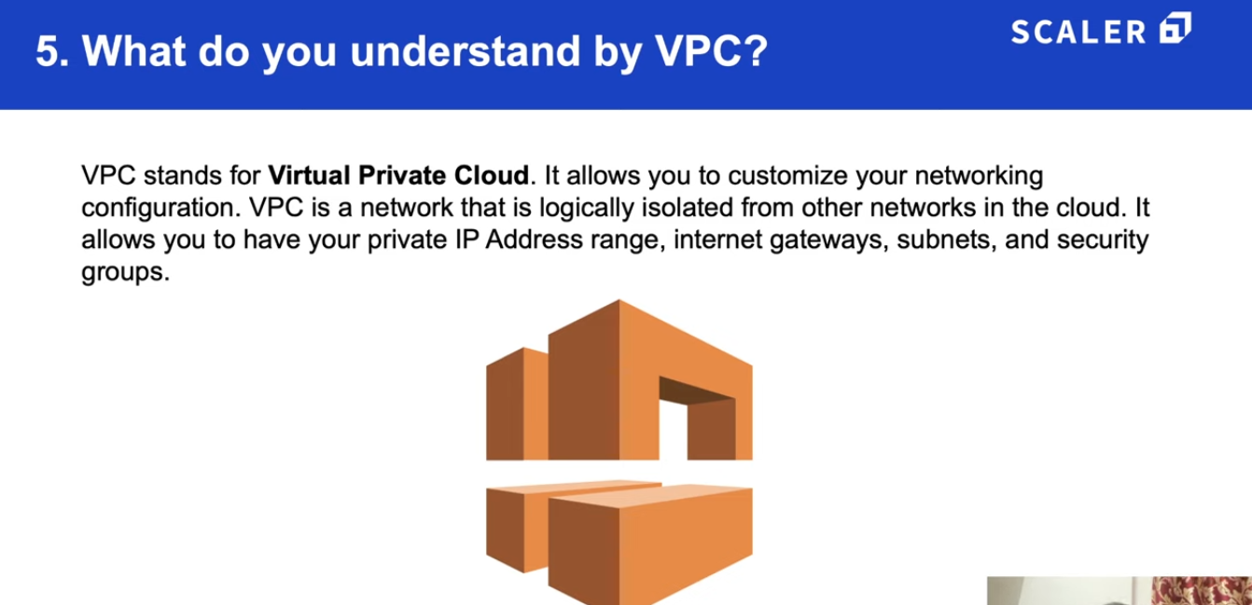

---------------------------------------------------------------------------------------------------------------------------

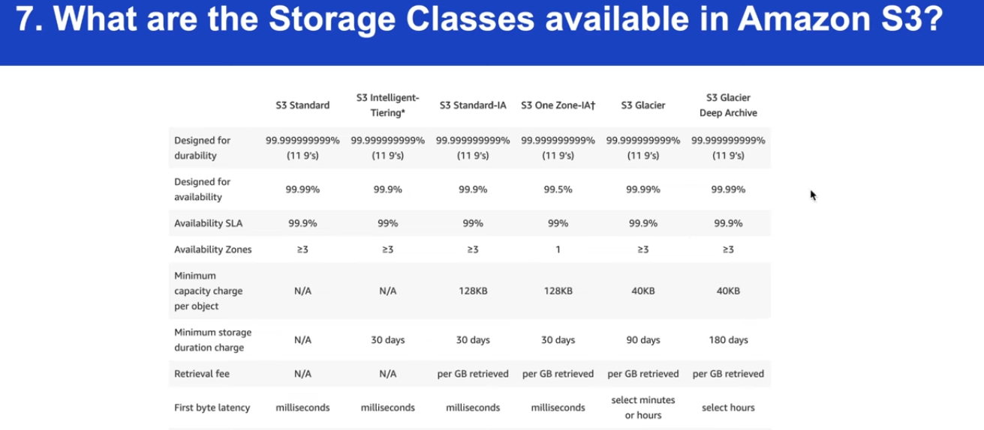

---------------------------------------------------------------------------------------------------------------------------

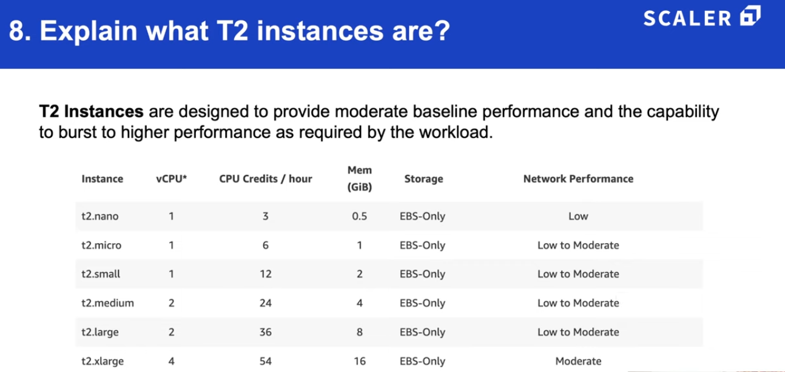

---------------------------------------------------------------------------------------------------------------------------

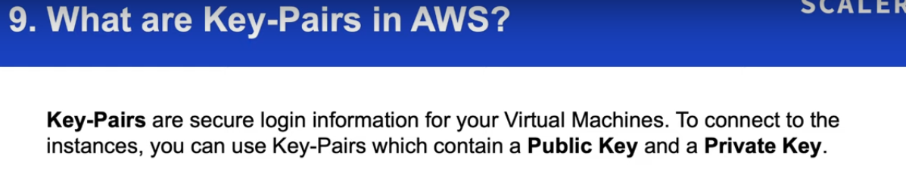

---------------------------------------------------------------------------------------------------------------------------

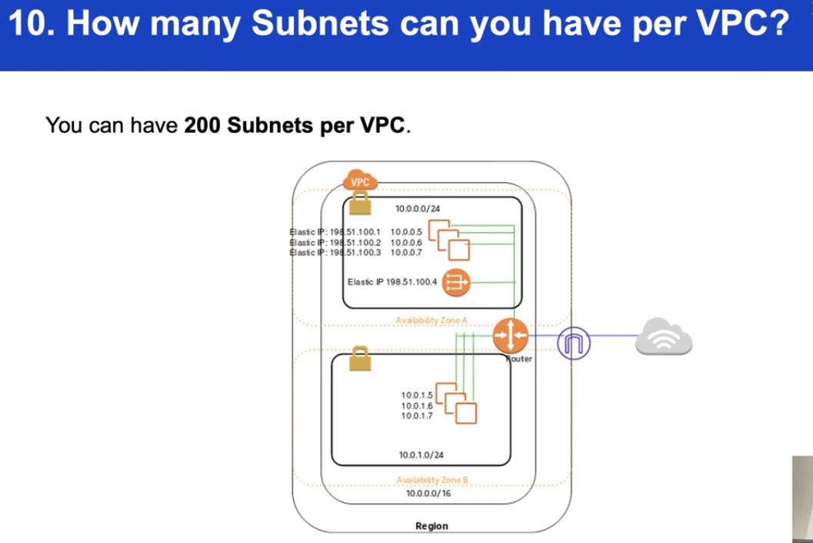

---------------------------------------------------------------------------------------------------------------------------

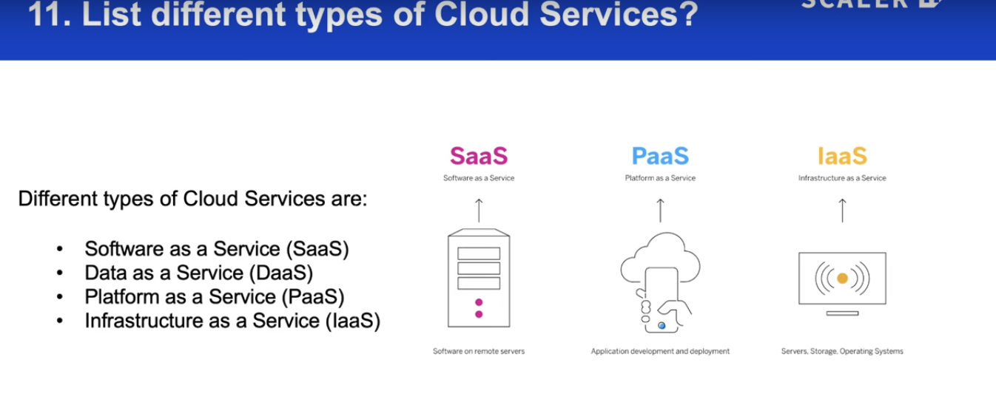

---------------------------------------------------------------------------------------------------------------------------

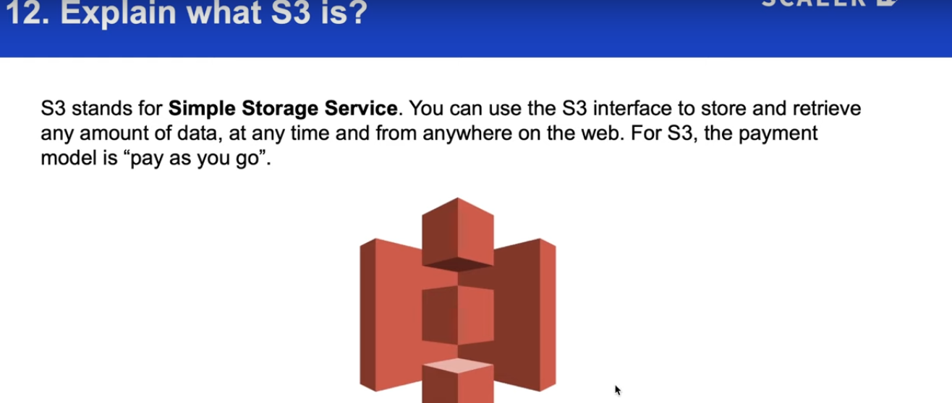

---------------------------------------------------------------------------------------------------------------------------

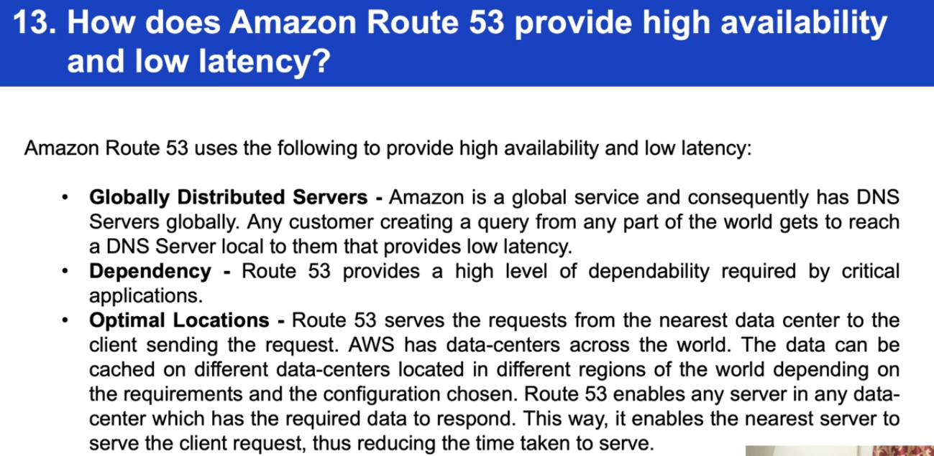

---------------------------------------------------------------------------------------------------------------------------

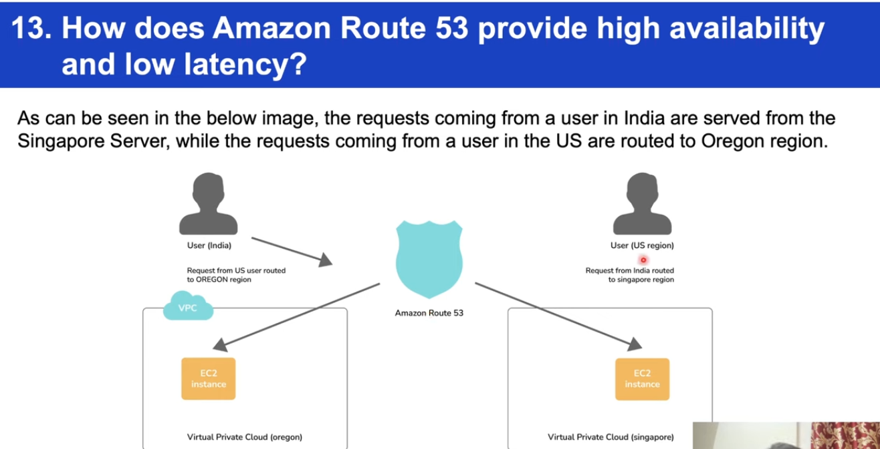

---------------------------------------------------------------------------------------------------------------------------

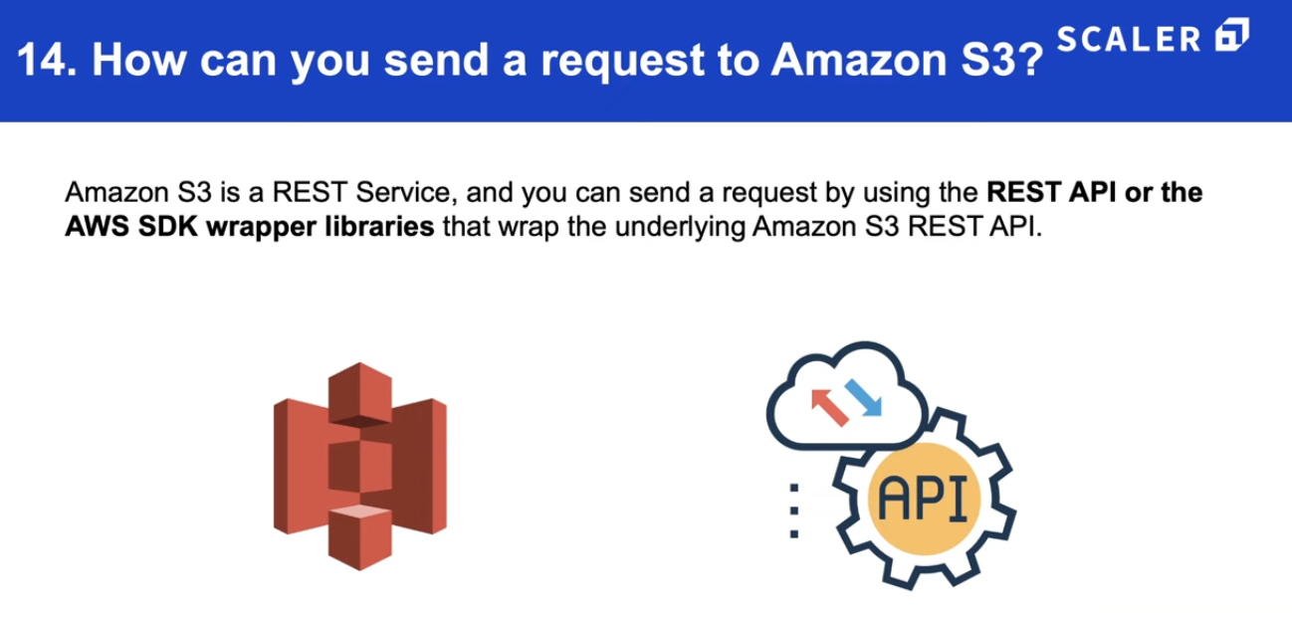

---------------------------------------------------------------------------------------------------------------------------

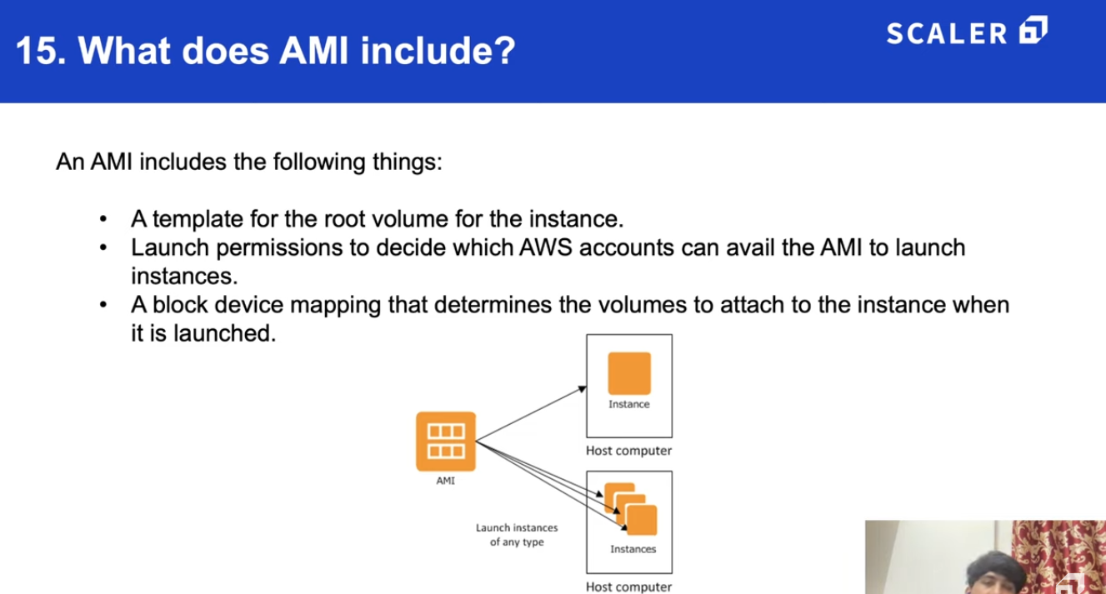

---------------------------------------------------------------------------------------------------------------------------

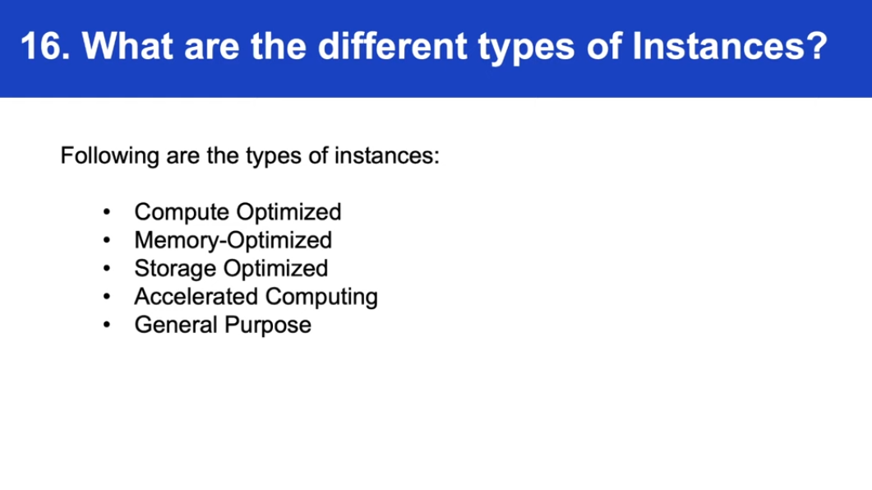

---------------------------------------------------------------------------------------------------------------------------

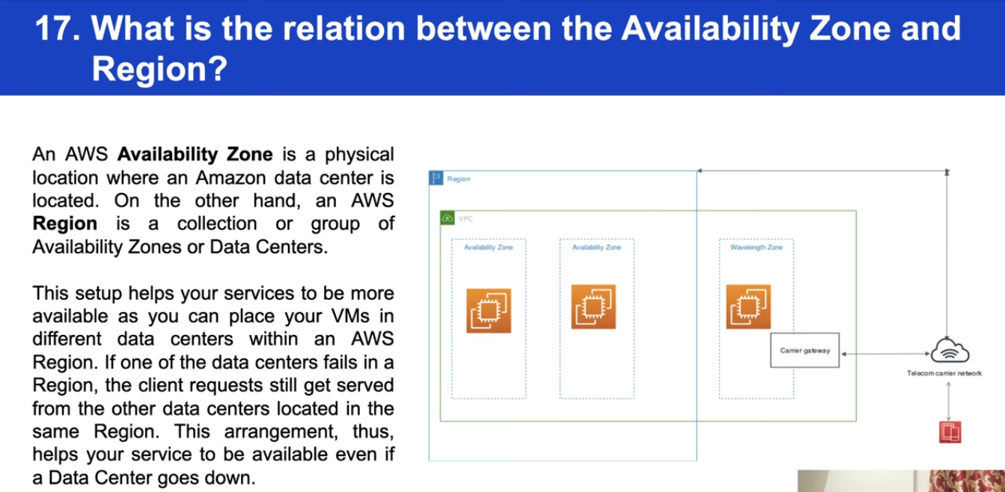

---------------------------------------------------------------------------------------------------------------------------

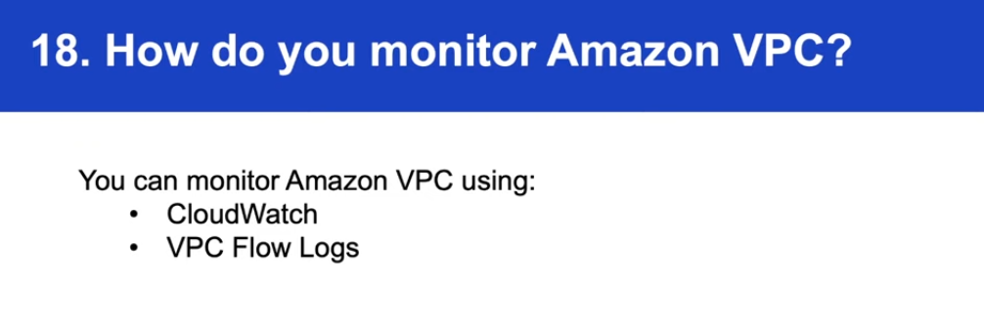

---------------------------------------------------------------------------------------------------------------------------

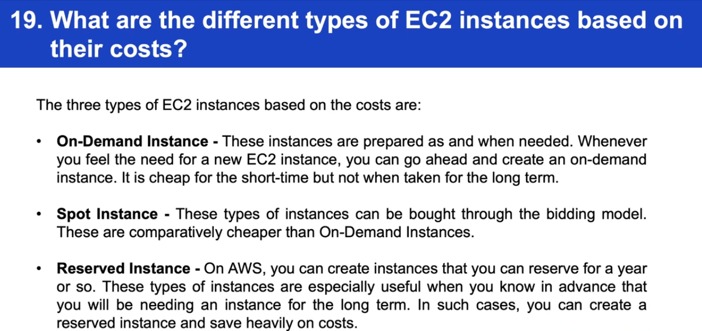

---------------------------------------------------------------------------------------------------------------------------

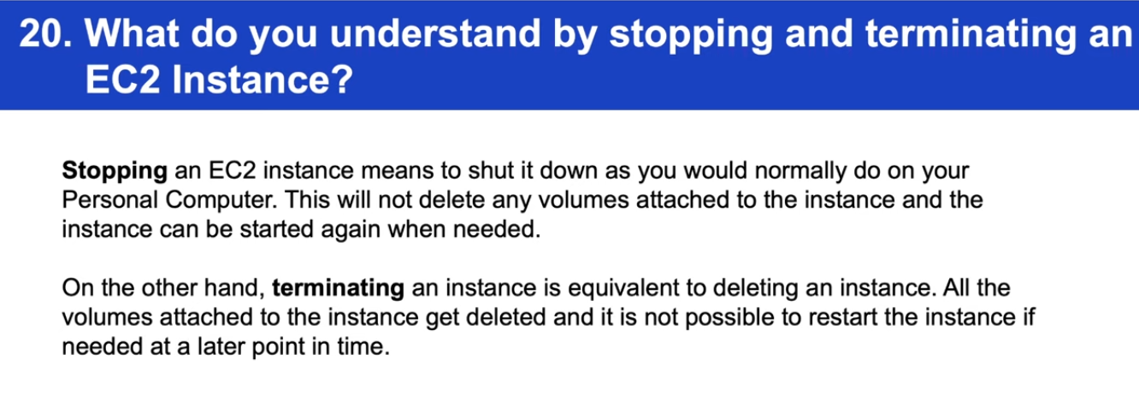

---------------------------------------------------------------------------------------------------------------------------

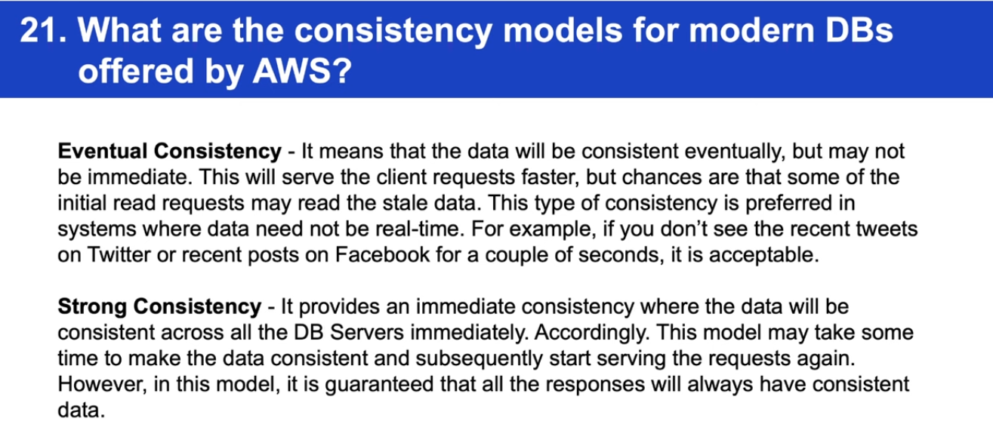

---------------------------------------------------------------------------------------------------------------------------

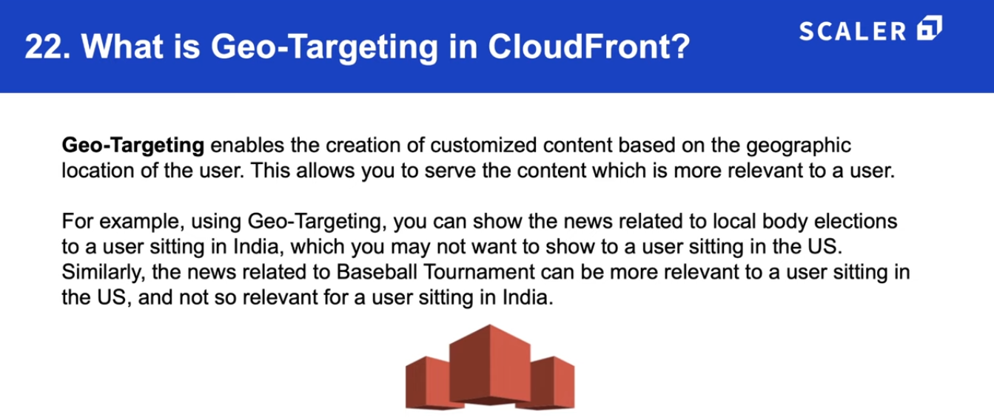

---------------------------------------------------------------------------------------------------------------------------

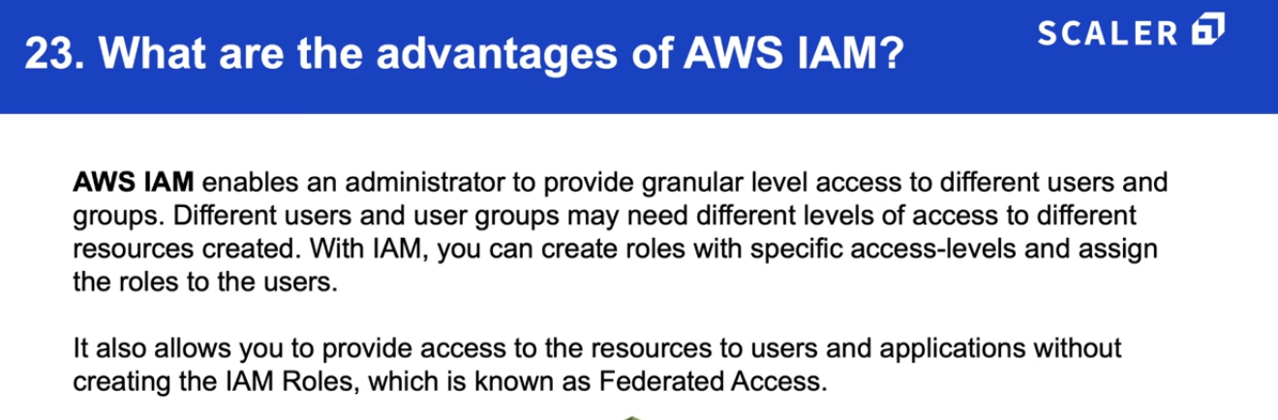

---------------------------------------------------------------------------------------------------------------------------

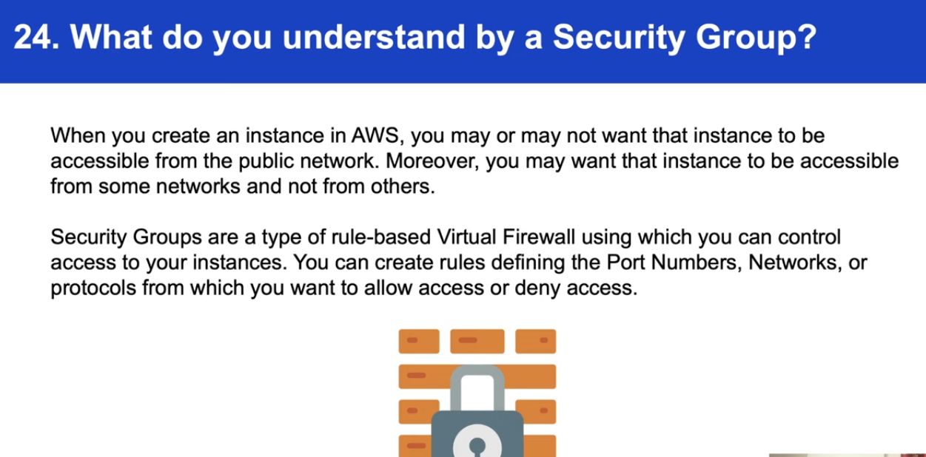

---------------------------------------------------------------------------------------------------------------------------

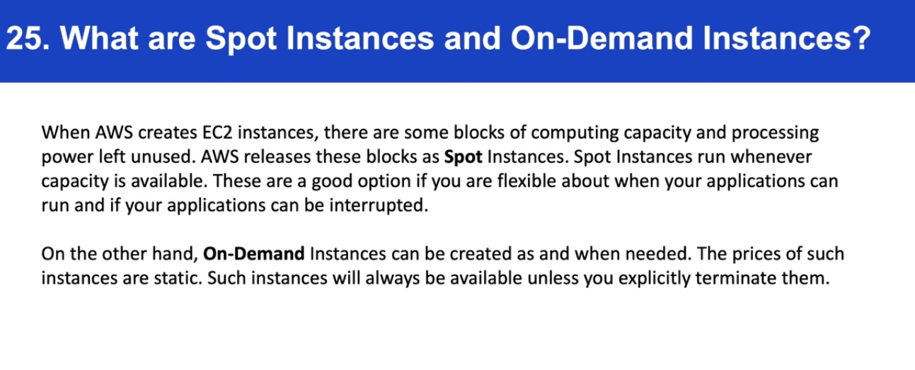

---------------------------------------------------------------------------------------------------------------------------

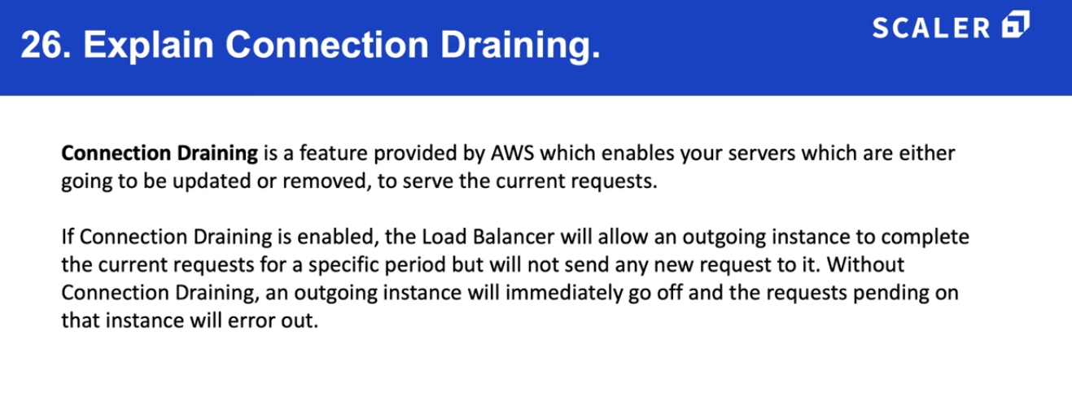

---------------------------------------------------------------------------------------------------------------------------

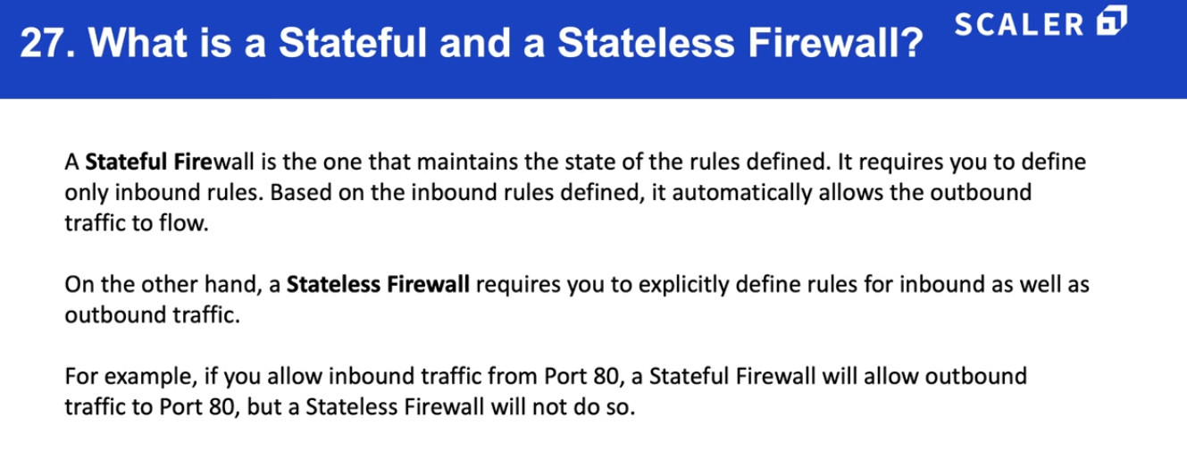

---------------------------------------------------------------------------------------------------------------------------

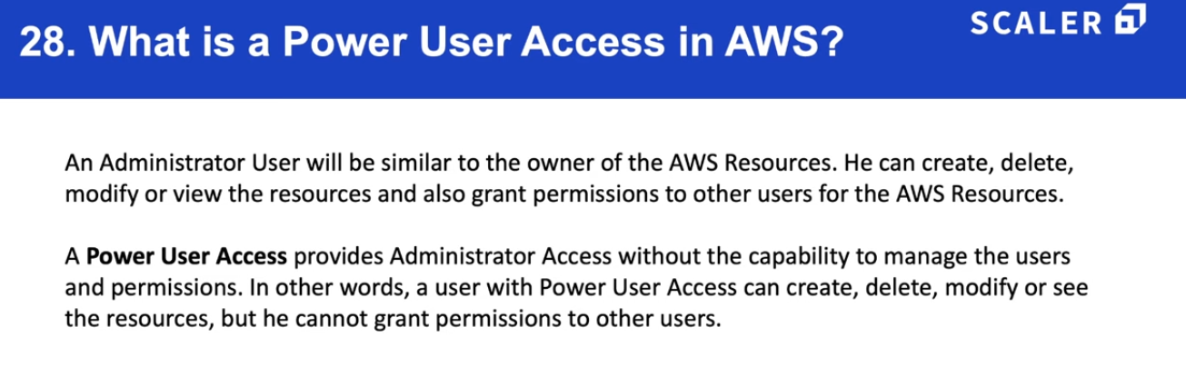

---------------------------------------------------------------------------------------------------------------------------

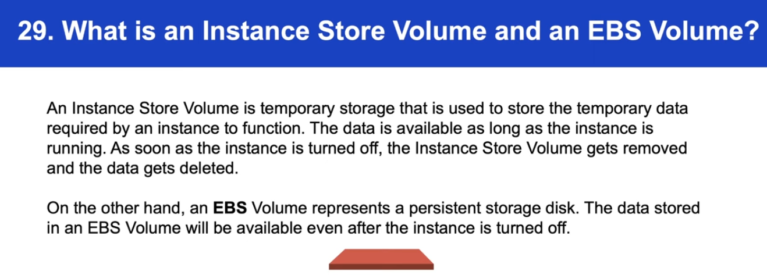

---------------------------------------------------------------------------------------------------------------------------

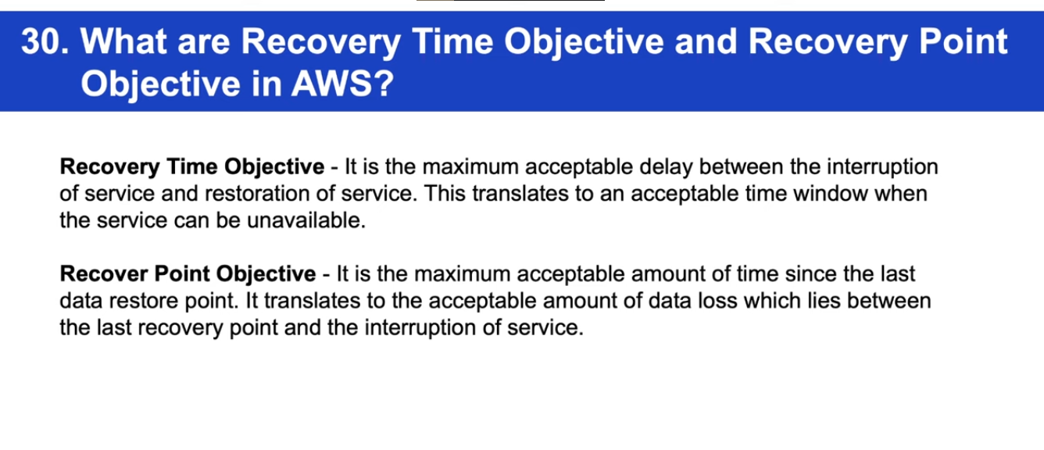

---------------------------------------------------------------------------------------------------------------------------

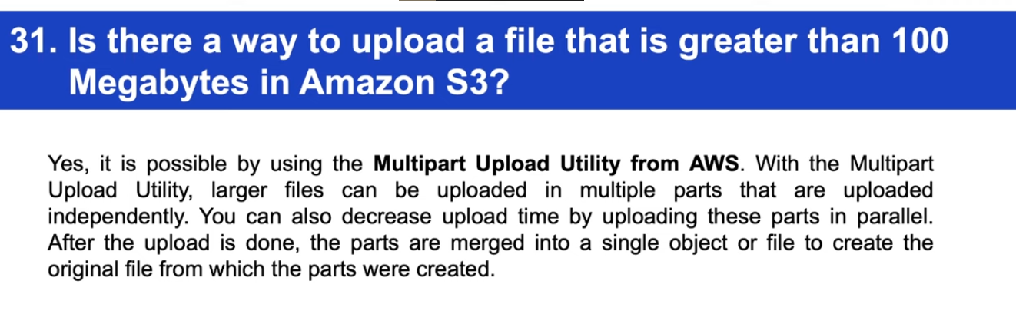

---------------------------------------------------------------------------------------------------------------------------

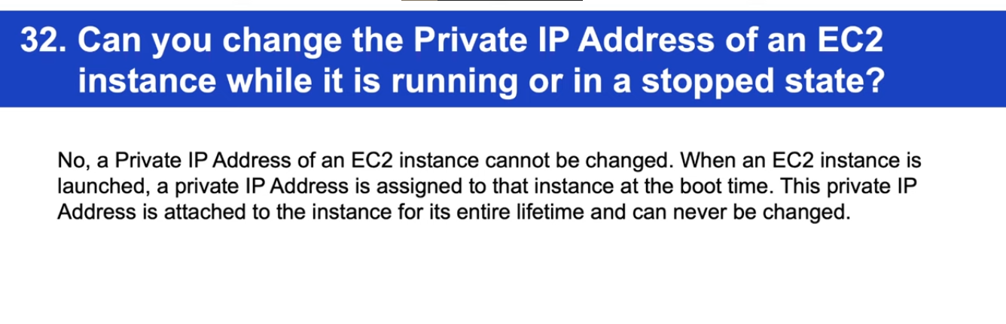

---------------------------------------------------------------------------------------------------------------------------

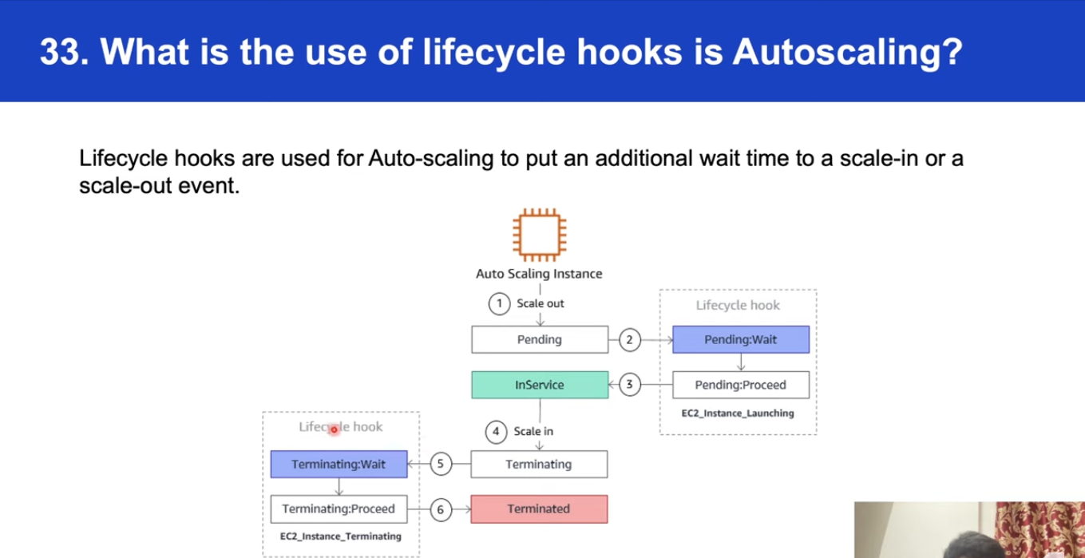

---------------------------------------------------------------------------------------------------------------------------

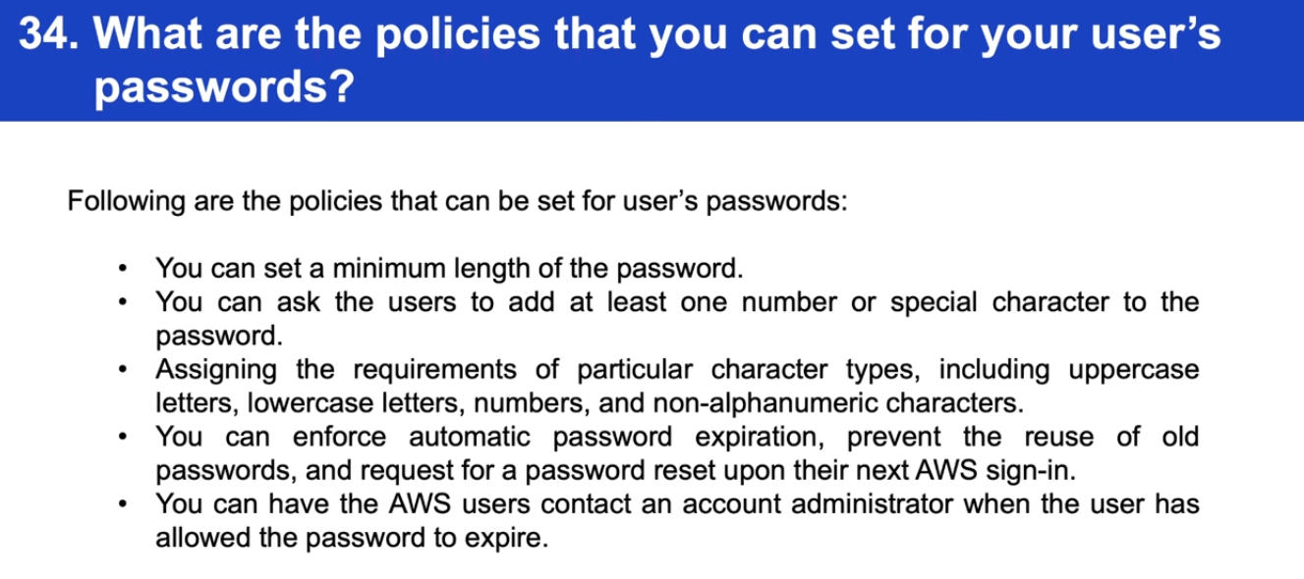

**=====================================================================**

**How to write AWS lambda logs?**

**By default, AMS lambda writes log to cloud watch. We have to provide IAM role and permission for CloudWatch service.**

**CloudWatch - Amazon *CloudWatch* allows you to collect, access, and correlate this data on a single platform from across all your *AWS* resources, applications, and services.**

**CloudWatch collects monitoring and operational data in the form of logs, metrics, and events. You get a unified view of operational health and gain complete visibility of your AWS resources, applications, and services running on AWS and on-premises. You can use CloudWatch to detect anomalous behavior in your environments, set alarms, visualize logs and metrics side by side, take automated actions, troubleshoot issues, and discover insights to keep your applications running smoothly.**

**-------------------------------------------------------------------------------------------------------**

**Life cycle of AWS lambda**

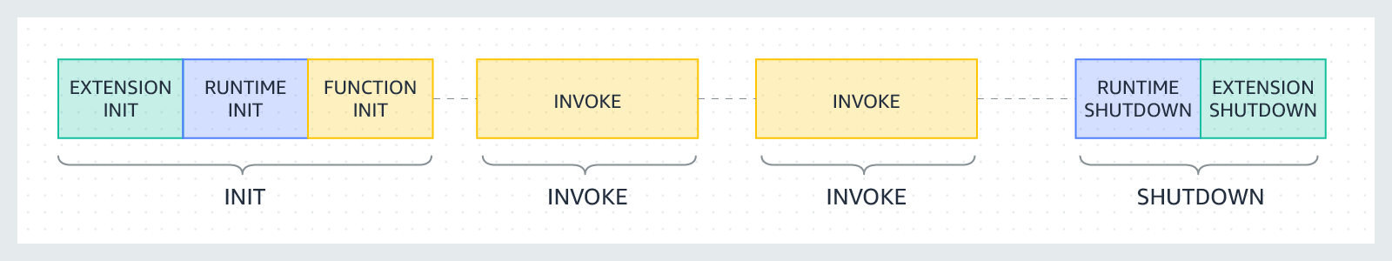

**The lifecycle of the execution environment includes the following phases:**

* **Init: In this phase, Lambda creates or unfreezes an execution environment with the configured resources, downloads the code for the function and all layers, initializes any extensions, initializes the runtime, and then runs the function’s initialization code (the code outside the main handler). The Init phase happens either during the first invocation, or in advance of function invocations if you have enabled** [**provisioned concurrency**](https://docs.aws.amazon.com/lambda/latest/dg/provisioned-concurrency.html)**.  
    
   The Init phase is split into three sub-phases: Extension init, Runtime init, and Function init. These sub-phases ensure that all extensions and the runtime complete their setup tasks before the function code runs.**
* **Invoke: In this phase, Lambda invokes the function handler. After the function runs to completion, Lambda prepares to handle another function invocation.**
* **Shutdown: This phase is triggered if the Lambda function does not receive any invocations for a period of time. In the Shutdown phase, Lambda shuts down the runtime, alerts the extensions to let them stop cleanly, and then removes the environment. Lambda sends a Shutdown event to each extension, which tells the extension that the environment is about to be shut down.**
* **Each phase starts with an event that Lambda sends to the runtime and to all registered extensions. The runtime and each extension indicate completion by sending a Next API request. Lambda freezes the execution environment when the runtime and each extension have completed and there are no pending events.**

**-------------------------------------------------------------------------------------------------------**

**IF some python libraries don’t work in AWS lambda, what will you do?**

## **Short description**

**You typically receive this error when your Lambda environment can't find the specified library in the Python code. This is because Lambda isn't prepackaged with all Python libraries.**

**To resolve this error, create a deployment package or Lambda layer that includes the libraries that you want to use in your Python code for Lambda.**

## **Resolution**

**Note: The following steps show you how to create a Lambda layer rather than a deployment package. This is because you can reuse the Lambda layer across multiple Lambda functions. Each Lambda runtime adds specific /opt directory folders to the PATH variable. If the layer uses the same folder structure, then your Lambda function's code can access the layer content without specifying the path.**

**It's a best practice to create a Lambda layer on the same** [**operating system**](https://docs.aws.amazon.com/lambda/latest/dg/lambda-runtimes.html) **that your Lambda runtime is based on. For example, Python 3.8 is based on an Amazon Linux 2 Amazon Machine Image (AMI). However, Python 3.7 and Python 3.6 are based on the Amazon Linux AMI.**

**To create a Lambda layer for a Python 3.8 library, do the following:**

**1. In the** [**AWS Cloud9 console**](https://console.aws.amazon.com/cloud9/)**, create an Amazon Elastic Compute Cloud (Amazon EC2) instance with Amazon Linux 2 AMI. For instructions, see** [**Creating an EC2 environment**](https://docs.aws.amazon.com/cloud9/latest/user-guide/create-environment-main.html) **in the AWS Cloud9 User Guide.**

**2.** [**Create an AWS Identity and Access Management (IAM) policy**](https://docs.aws.amazon.com/IAM/latest/UserGuide/access_policies_create.html#access_policies_create-json-editor) **that grants permissions to call the** [**PublishLayerVersion**](https://docs.aws.amazon.com/lambda/latest/dg/API_PublishLayerVersion.html) **API operation.**

**Example IAM policy statement that grants permissions to call the PublishLayerVersion API operation**

**{**

**"Version": "2012-10-17",**

**"Statement": [**

**{**

**"Sid": "VisualEditor0",**

**"Effect": "Allow",**

**"Action": "lambda:PublishLayerVersion",**

**"Resource": "*"**

**}**

**]**

**}**

**3.** [**Create an IAM role**](https://docs.aws.amazon.com/AWSEC2/latest/UserGuide/iam-roles-for-amazon-ec2.html) **and** [**attach the IAM policy to the role**](https://docs.aws.amazon.com/IAM/latest/UserGuide/access_policies_manage-attach-detach.html#attach-detach-etc-terminology)**. Then,** [**attach the IAM role to the Amazon EC2 instance**](https://aws.amazon.com/premiumsupport/knowledge-center/assign-iam-role-ec2-instance/)**.**

**Note: Your EC2 instance now has permissions to upload Lambda layers for the PublishLayerVersion API call.**

**4.** [**Open your AWS Cloud9 Amazon EC2 environment**](https://docs.aws.amazon.com/cloud9/latest/user-guide/open-environment.html)**. Then, install Python 3.8 and pip3 by running the following commands:**

**$ sudo amazon-linux-extras install python3.8**

**$ curl -O https://bootstrap.pypa.io/get-pip.py**

**$ python3.8 get-pip.py --user**

**5. Create a python folder by running the following command:**

**$ mkdir python**

**6. Install the Pandas library files into the python folder by running the following command:**

**Important: Replace Pandas with the name of the Python library that you want to import.**

**$ python3.8 -m pip install pandas -t python/**

**7. Zip the contents of the python folder into a layer.zip file by running the following command:**

**$ zip -r layer.zip python**

**8. Publish the Lambda layer by running the following command:**

**Important: Replace us-east-1 with the AWS Region that your Lambda function is in.**

**$ aws lambda publish-layer-version --layer-name pandas-layer --zip-file fileb://layer.zip --compatible-runtimes python3.8**

**-----------------------------------------------------------------------------------------------------------**

# **Best practices for working with AWS Lambda functions**

[**PDF**](https://docs.aws.amazon.com/lambda/latest/dg/lambda-dg.pdf#best-practices)[**RSS**](https://docs.aws.amazon.com/lambda/latest/dg/lambda-updates.rss)

**The following are recommended best practices for using AWS Lambda:**

**Topics**

* [**Function code**](https://docs.aws.amazon.com/lambda/latest/dg/best-practices.html#function-code)
* [**Function configuration**](https://docs.aws.amazon.com/lambda/latest/dg/best-practices.html#function-configuration)
* [**Metrics and alarms**](https://docs.aws.amazon.com/lambda/latest/dg/best-practices.html#alarming-metrics)
* **Working with streams**

**---------------------------------------------------------------------------------------------------------------**

**Classifiers in AWS**

**A classifier reads the data in a data store. If it recognizes the format of the data, it generates a schema. The classifier also returns a certainty number to indicate how certain the format recognition was. AWS Glue provides a set of built-in classifiers, but you can also create custom classifiers.**

**===============================================================**

**AWS QuickSight -- AN BI tool to build dashboards.**

**SPICE (Super-fast, Parallel, In-memory Calculation Engine)**

**----------------------------------------------------------------------------------------------------------------------------**

**AWS SageMaker - To use jyputer notebook.**

Amazon SageMaker is a cloud machine-learning platform that was launched in November 2017. SageMaker enables developers to create, train, and deploy machine-learning models in the cloud. SageMaker also enables developers to deploy ML models on embedded systems and edge-devices.

----------------------------------------------------------------------------------------------------------------------------

**AWS Comprehend**

Amazon Comprehend is **a natural language processing (NLP) service that uses machine learning to find insights and relationships in text**, no machine learning experience is required. Amazon Comprehend uses machine learning to help you uncover the insights and relationships in your unstructured data.

---------------------------------------------------------------------------------------------------------------------------

How many types of storage classes are available in S3?

S3 Storage Classes can be configured at the object level, and a single bucket can contain objects stored across **S3 Standard, S3 Intelligent-Tiering(cheapest one), S3 Standard-IA, and S3 One Zone-IA**..

**How AWS Charge** - The money is charged based on the amount of time the code runs.

---------------------------------------------------------------------------------------------------------------------------

Classifiers for data handling

https://docs.aws.amazon.com/glue/latest/dg/add-classifier.html

---------------------------------------------------------------------------------------------------------------------------

Types of dimension tables.

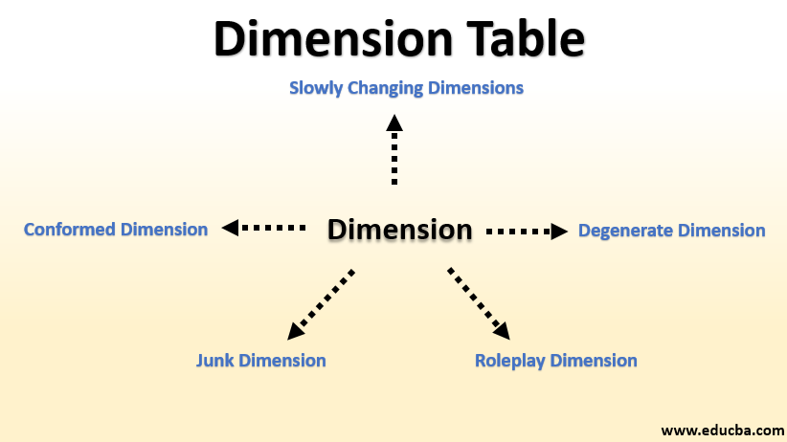

---------------------------------------------------------------------------------------------------------------------------

### Monolithic vs. Microservices Architecture

With monolithic architectures, all processes are tightly coupled and run as a single service. This means that if one process of the application experiences a spike in demand, the entire architecture must be scaled. Adding or improving a monolithic application’s features becomes more complex as the code base grows. This complexity limits experimentation and makes it difficult to implement new ideas. Monolithic architectures add risk for application availability because many dependent and tightly coupled processes increase the impact of a single process failure.

**With a microservices architecture, an application is built as independent components that run each application process as a service.** These services communicate via a well-defined interface using lightweight APIs. Services are built for business capabilities and each service performs a single function. Because they are independently run, each service can be updated, deployed, and scaled to meet demand for specific functions of an application.

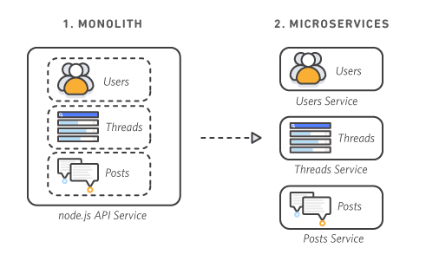

---------------------------------------------------------------------------------------------------------------------------

# **Difference between Process and Thread**

**Process:** Processes are basically the programs that are dispatched from the ready state and are scheduled in the CPU for execution. PCB([Process Control Block](https://www.geeksforgeeks.org/process-table-and-process-control-block-pcb/)) holds the concept of process. A process can create other processes which are known as Child Processes. The process takes more time to terminate and it is isolated means it does not share the memory with any other process.

The process can have the following [states](https://www.geeksforgeeks.org/states-of-a-process-in-operating-systems/) new, ready, running, waiting, terminated, and suspended.

**Thread:** Thread is the segment of a process which means a process can have multiple threads and these multiple threads are contained within a process. A thread has three states: Running, Ready, and Blocked.

| S.NO | Process | Thread |
| --- | --- | --- |
| 1. | Process means any program is in execution. | Thread means a segment of a process. |
| 2. | The process takes more time to terminate. | The thread takes less time to terminate. |
| 3. | It takes more time for creation. | It takes less time for creation. |

---------------------------------------------------------------------------------------------------------------------------

# [**AWS Glue Crawler Cannot Extract CSV Headers**](https://stackoverflow.com/questions/54373335/aws-glue-crawler-cannot-extract-csv-headers)

ou can avoid header detection (which doesn't work when all columns are string type) by setting ContainsHeader to PRESENT when creating the custom classifier, and then provide the column names through Header. Once the custom classifier has been created you can assign this to the crawler. Since this is added to the crawler, you won't need to make changes to the schema after the fact, and don't risk these changes being overwritten in the next crawler run. Using boto3, it would look something like:

import boto3

glue = boto3.client('glue')

glue.create_classifier(CsvClassifier=

{ 'Name': 'contacts_csv',

'Delimiter': ',', 'QuoteSymbol': '"',

'ContainsHeader': 'PRESENT',

'Header': ['contact_id', 'person_id', 'type', 'value'] })

glue.create_crawler(Name=GLUE_CRAWLER, Role=role.arn, DatabaseName=GLUE_DATABASE, Targets={'S3Targets': [{'Path': s3_path}]}, Classifiers=['contacts_csv'])

---------------------------------------------------------------------------------------------------------------------------------